UTW | Vocabulary | Nursery  Autumn | Nursery  Spring | Nursery  Summer | Reception  Autumn | Reception  Spring | Reception  Summer
Links to KS1 Science | Head, shoulders, knees, toes, eyes, ears, mouth, nose, arms, legs,  cheeks, neck, elbows, hips  Healthy, fruit, vegetables, sleep, eat, drink, diet, exercise  Calf, foal, kitten, puppy, piglet, kid, lamb  Autumn, Winter, Spring, Summer, rain, sun, clouds, thunder, fog, frost, cold, hot, warm, change  Soft, hard, smooth, rough, bumpy, wet, dry, squishy, shiny, dull, waterproof  Plant, flower, grow, leaf, stem, root, sunflower, herbs, names of plants chosen, Animal, mammal, fish, insect, reptile, animal names of interest: snake, crocodile, cheetah, lion, bear, elephant, giraffe, koala, | Use all their senses in hands-on exploration of natural materials.  Explore collections of materials with similar and/or different properties.  Talk about the differences between materials and changes they notice | Explore how things work.  Plant seeds and care for growing plants.  Begin to understand the need to respect and care for the natural environment and all living things  Understand the key features of the life cycle of a plant and an animal. | Talk about what they see, using a wide vocabulary | Explore the natural world around them.  Describe what they see, hear, and feel whilst outside. | Understand the effect of changing seasons on the natural world around them | Explore the natural world around them, making observations and drawing pictures of animals and plants.  Know some similarities and differences between the natural world around them and contrasting environments, drawing on their experiences and what has been read in class.  Understand some important processes and changes in the natural world around them, including the seasons and changing states of matter.
Links to KS1 Geography | own, village, road, house, world, globe, earth, country, map, hot, sunny, cold, rain, snow, seasons, autumn, winter, spring, summer, weather, mountain, hill, beach, countryside, |  |  | Know that there are different countries in the world and talk about the differences they have experienced or seen in photos. |  | Draw information from a simple map.  Recognise some similarities and differences between life in this country and life in other countries.  Recognise some environments that are different to the one in which they live. | Describe their immediate environment using knowledge from observation, discussion, stories, non-fiction texts and maps.
Links to KS1 History | Past, present, future,  First, next, then Queen, king, ruler, palace, castle, London | Community, village, town, Firefighter, police officer, job, (names of other jobs in the community) Celebrate, festival, religion, Muslim, Christian, birthday, Christmas, Past, present, future,  First, next, then Queen, king, ruler, palace, castle, London | Show interest in different occupations.  Continue to develop positive attitudes about the differences between people  Explore and talk about different forces they can feel |  | Talk about members of their immediate family and community.  Name and describe people who are familiar to them.  Understand that some places are special to members of their community. | Comment on images of familiar situations in the past.  Compare and contrast characters from stories, including figures from the past  Recognise that people have different beliefs and celebrate special times in different ways. | Talk about the lives of the people around them and their roles in society.  Know some similarities and differences between things in the past and now, drawing on their experiences and what has been read in class.  Understand the past through settings, characters and events encountered in books read in class and storytelling  Know some similarities and differences between different religious and cultural communities in this country, drawing on their experiences and what has been read in class.  Explain some similarities and differences between life in this country and life in other countries, drawing on knowledge from stories, non-fiction texts and (when appropriate) maps.

Year 1
History | Skills
Chronology | 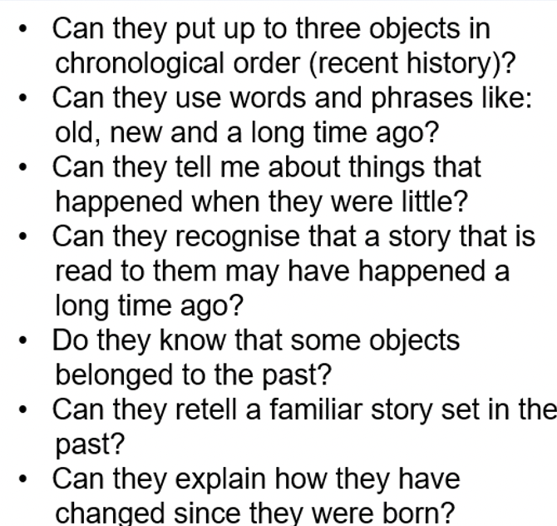
Contextual Knowledge and Conceptual Understanding | 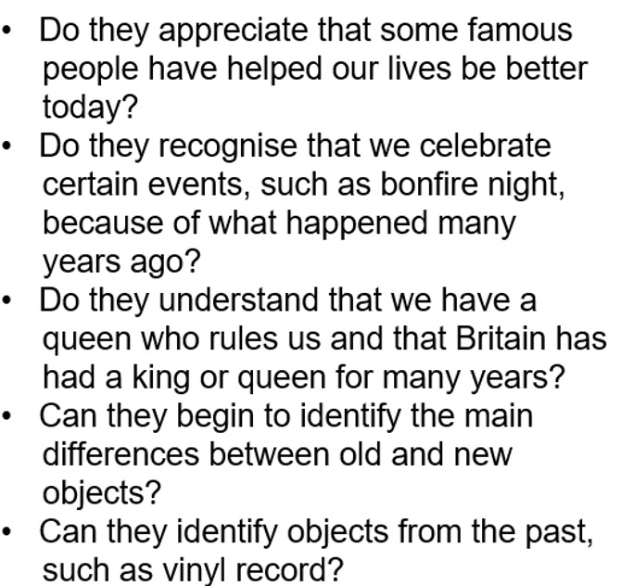
Historical Enquiry | 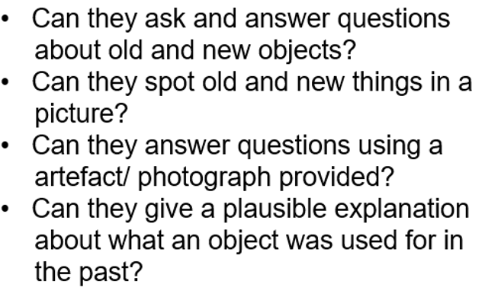

Year 1
Geography | Skills
Locational Knowledge | 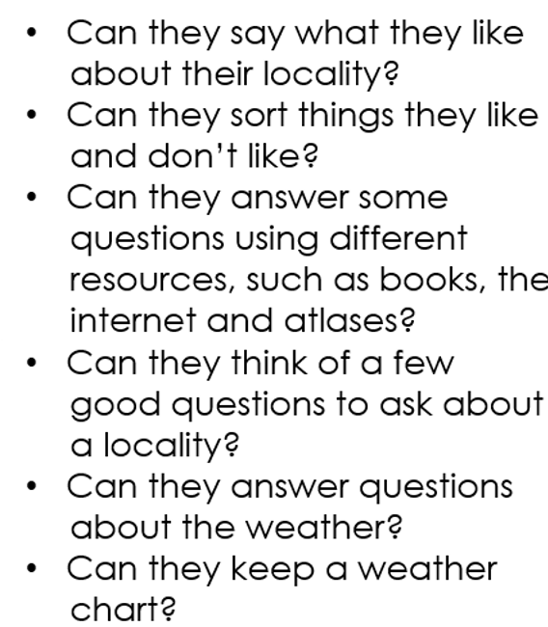
Human and Physical Geography | 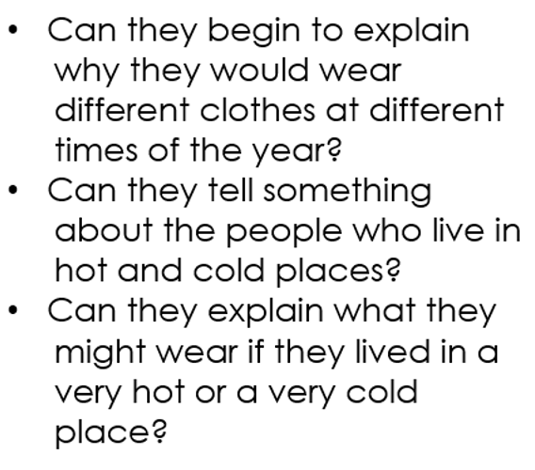
Geographical  Skills and Fieldwork | 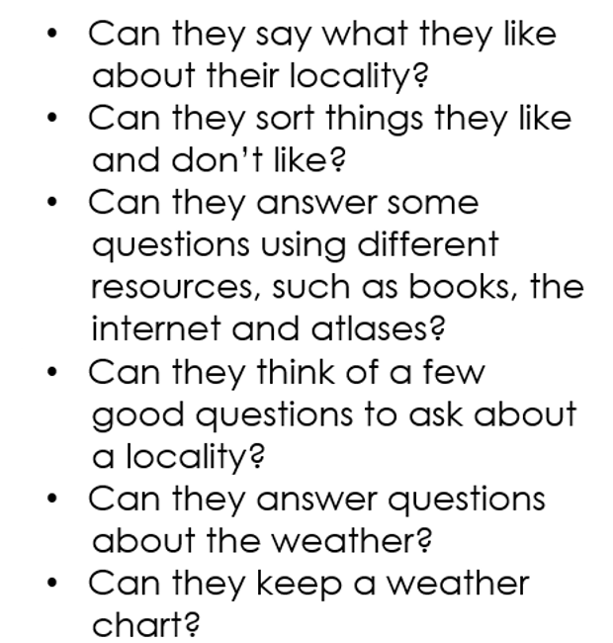

Year 1
Science | Skills
Locational Knowledge | countries of the UK and its surrounding seas  Name the capital cities of the UK.  Locate the UK on a map  Name the seven continents and five oceans.
Human and Physical Geography | Identify basic seasonal weather patterns in the UK  Identify the location of hot and cold areas of the world in relation to the equator and North and South poles.  Use basic geographical vocabulary to describe physical features of the local environment (forest, hill, mountain, beach, valley, vegetation)  Use basic geographical vocabulary to describe human features of local environment: city, town, village, factory, farm, house, retail (shop / café).
Geographical  Skills and Fieldwork | Use simple fieldwork and observational skills to study the geography of their school and its grounds and key physical and human features of its surrounding environment  Use world maps, atlases, and globes to identify the United Kingdom and its countries.  Use world maps, atlases, and globes to identify continents and oceans around the world.

