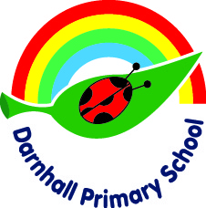

**Darnhall Primary School**

**School Council**

Following a democratic voting process, classes from Year 1 to Year 6 chose their school councillors for the academic year.

The School Council is a group of children who will try to implement changes to make the school a better place. Through talking to the pupils in their class they will know what the children think and what they would like to see improved within the school.

We have found that the best ideas come from the pupils as they can give a child’s perspective and suggest ways in which the school could be improved.

The School Councillors will have regular meetings to share the thoughts and ideas of the pupils in their classes. They will then report back to their classes, letting them know what has been discussed. They will also have meetings with Mrs Tomlinson to put forward the ideas, thoughts and wishes of all the pupils in school.

Throughout the year, there will be opportunities for the School Council members to become involved in events that involve pupils from other schools in Winsford, as well as events that involve pupils from across the county.