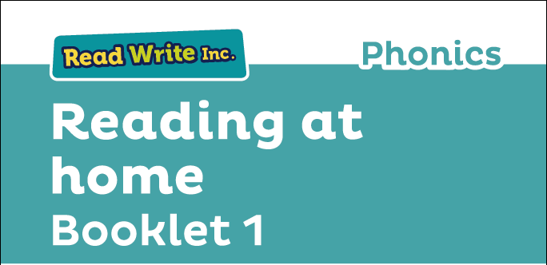

Glossary
Fred Talk – sounding out the word before reading (blending)

sound-blending – putting sounds together to make a word,
e.g. c–a–t cat

special friends – sounds written with more than one letter,
  - sh, ng, qu, ch

Speed Sounds – the individual sounds that make up words

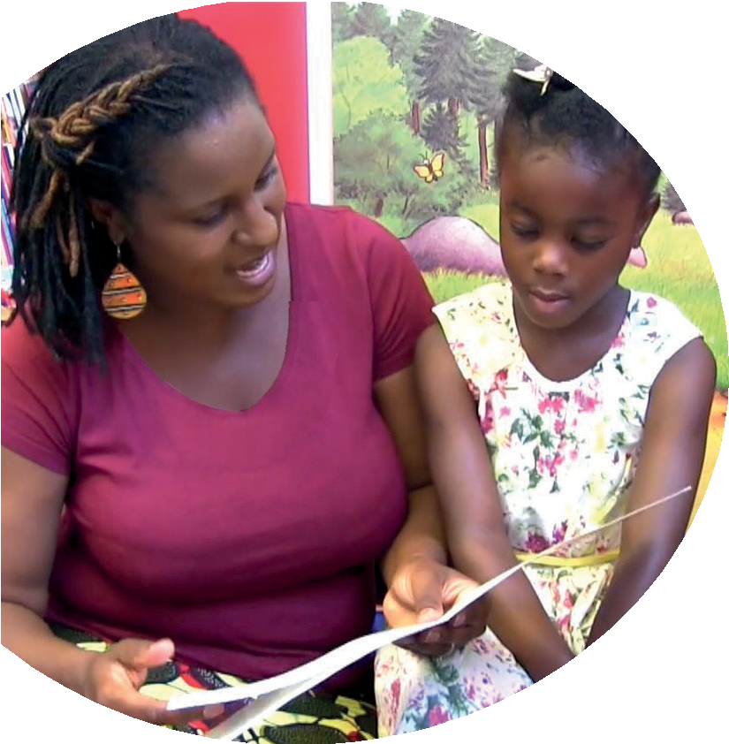
Read stories to your child with feeling! The more you love the story, the more your child will love reading.

Booklet 1 tells you how to help your child:
- read Set 1 Speed Sounds
- blend sounds into words
- read the Blending Books
- read Red, Green and Purple Storybooks.

Your child is learning to read with Read Write Inc. Phonics. This booklet shows you how you can get your child off to a quick start.
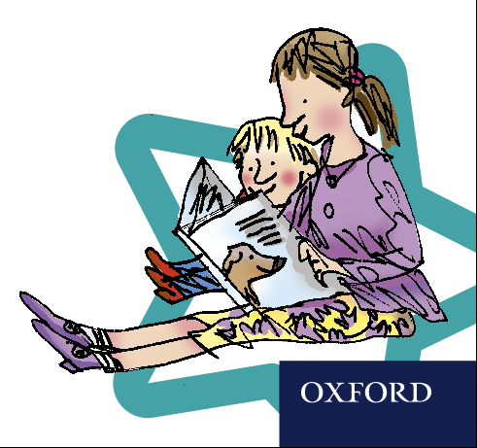
Your child will learn to read in a very simple way. He or she will learn to:
- Read letters by their ‘sounds’

Blend these sounds into words
- Read the words in a story.

www.ruthmiskin.com/parents has many videos to help you help your child.
For more information on Read Write Inc., please talk to the Read Write Inc. manager in your child’s school or visit www.readwriteinc.com.

8

1

How to listen to your child read
How will my child learn to read?

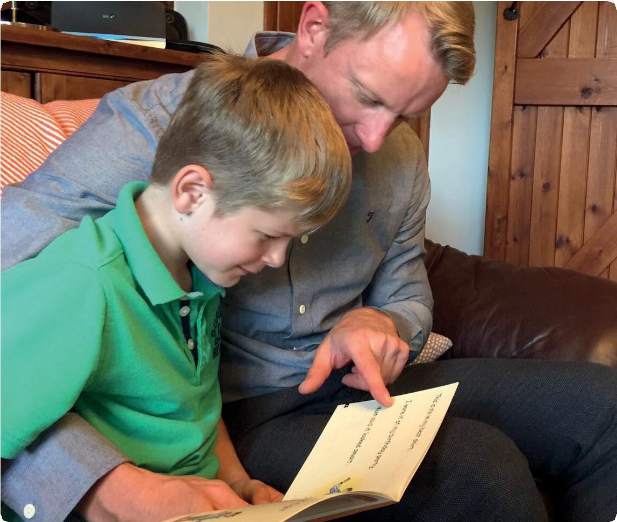
First, your child will learn to read:
- Set 1 Speed Sounds: these are sounds written with one letter:
m a s d t i n p g o c k u b f e l h r j v
y w z x and sounds written with two letters • (your child will call these ‘special friends’): sh th ch
qu ng nk ck
- Words containing these sounds, by sound-blending,
e.g. m–a–t mat, c–a–t cat, g–o–t got, f–i–sh ﬁsh,
s–p–o–t spot, b–e–s–t best, s–p–l–a–sh splash
- Blending Books and Red, Green and Purple Storybooks.

- Do not read the book aloud before your child reads it to you.
- Ask your child to read the sounds and words before he or she reads the story.
- When your child reads the story, ask your child to sound out
- the words that he or she can’t read automatically. Don’t allow your child to struggle too much. Praise your child when he or
she succeeds.
- Read back each sentence or page to keep the plot moving. (Your child’s energy is going into reading the words not the story.)
- Do not ask your child to guess the word by using the pictures.
- Do it all with patience and love!
Second, he or she will learn to read:
- Set 2 Speed Sounds: ay ee igh ow oo oo ar or air ir ou oy
- Words containing these sounds
- Pink, Orange and Yellow Storybooks.

Third, he or she will learn to read:
- Set 3 Speed Sounds: ea oi a-e i-e o-e u-e aw are ur er ow ai oa ew ire ear ure
- Words containing these sounds
- Blue and Grey Storybooks.

We have a storytime every day at school so children develop a love of stories. We hope that you will do the same by reading a bedtime story to your child every night. We have wonderful books in school for you to borrow.
Your child will be taught to say the sound for the letter and not the letter name, so ‘m’ as in ‘mat’, not ‘em’;
‘s’ as in ‘sun’ not ‘es’.

Help your child read the Sound Blending Books
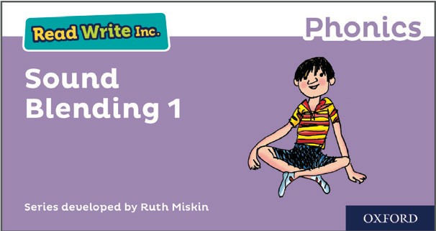

Ask your child to read each word in sounds (Fred Talk) and then say the word. Then, he or she can turn over and check if they’re right.

Help your child read the Storybooks

Black and White Storybooks
As soon as your child starts to read the Read Write Inc. Phonics Storybooks, your child will bring home a black and white Storybook. This is a copy of the colour version he or she will have read at school.
Your child will have read this story three times with their reading teacher, so should be able to read the story conﬁdently.
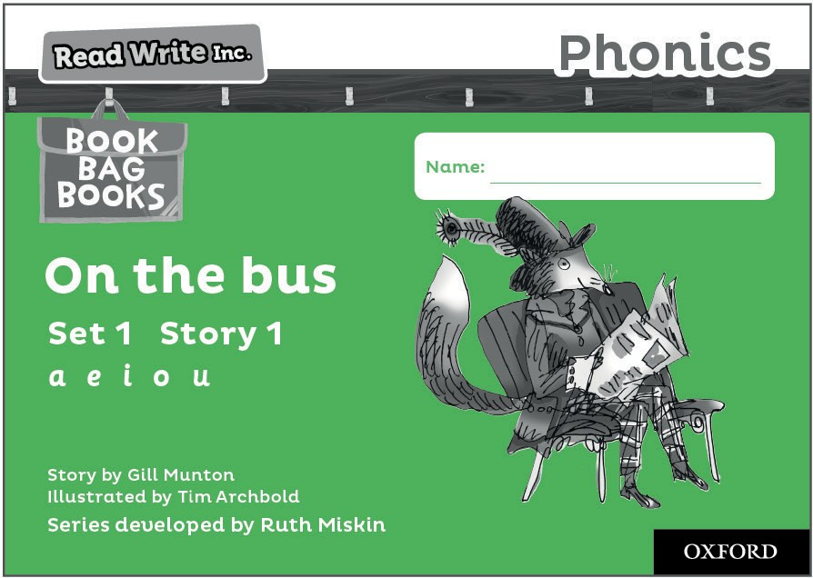

A brief explanation of how to follow the activities is included in the books. These will be sent home and changed on a Monday and on a Thursday.

Book Bag Books
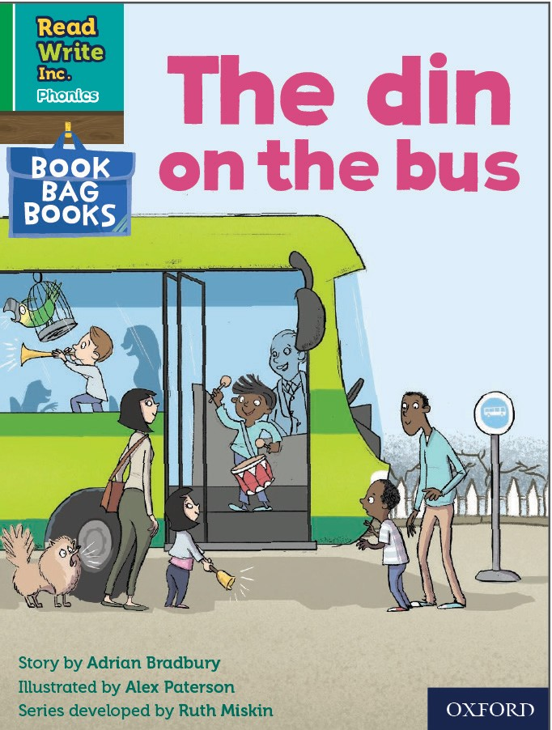

Your child may also bring home a Book Bag Book. This book builds upon the ideas and many of the words in the Storybook he or she has just read. Your child will need more support in reading this book.
Again, explanations of how to use the activities are included in the books. These will be sent home and changed on a Monday.

1. Help your child read the Set 1 Speed Sounds
Before you get going, visit www.ruthmiskin.com/parents to practise saying the sounds clearly. The more clearly you say the sounds, the more quickly your child will learn them.

Important: We say ‘mmmm’ not ‘muh’ and ‘lllll’ not ‘luh’ when teaching the sounds. This really helps children when they learn to blend sounds together to read words.

Your child will bring home the Set 1 Speed Sounds cards or a
My Set 1 Speed Sounds Book.
You’ll see that each sound is drawn in the shape of a picture. For example:
- ‘s’ is in the shape of a snake
- ‘d’ is in the shape of a dinosaur
- ‘a’ is in the shape of an apple
- ‘m’ is in the shape of two mountains.
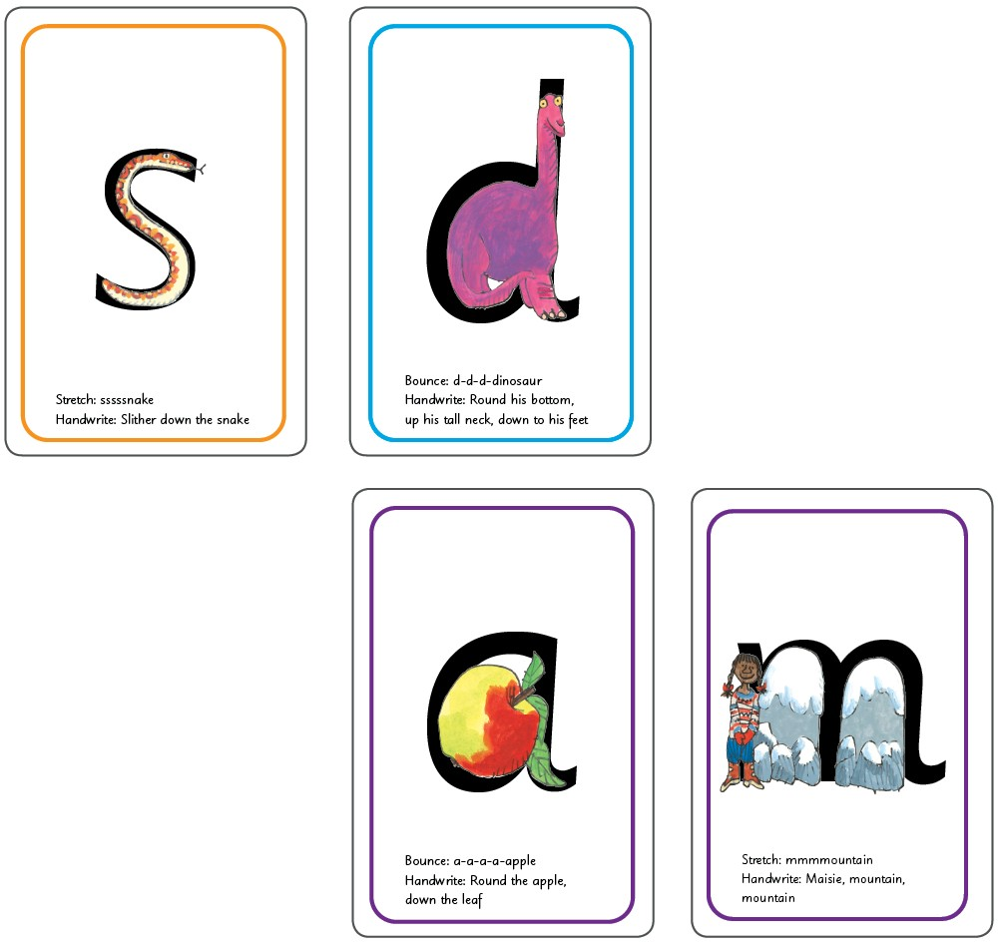

Using the Set 1 Speed Sounds cards

The name of each picture is written on the back of the cards.

- Ask your child to say the name of the picture on the back of each card, e.g. a-a-a-apple, sssssnake, getting quicker each time.
- Help your child to say the sound hidden behind each picture,
e.g. ‘s’ is behind the snake. Repeat until your child can do this quickly.
- Help your child to say the sounds on the letter side, getting quicker each time. If he or she forgets, turn back to the picture side.
When your child can say the sounds without turning over to check, increase the speed!
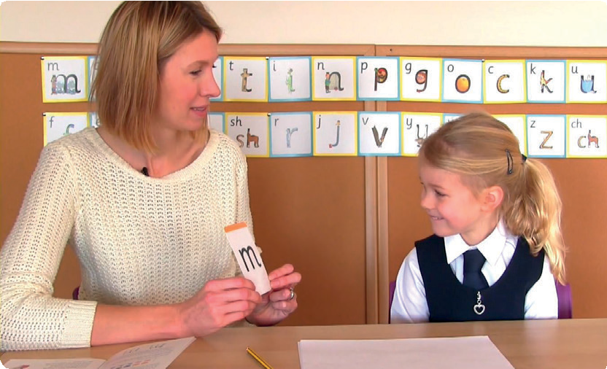
2. Help your child to read words
Once your child can read Set 1 Speed Sounds conﬁdently, he or she can learn to read words. First, your child is introduced to a toy frog called Fred. Fred can only say the sounds in a word and needs your child to help him read the word. So, when you hear your child say ‘Fred Talk’, you’ll know this means sounding out the word.
You can help your child to read words by following these steps:
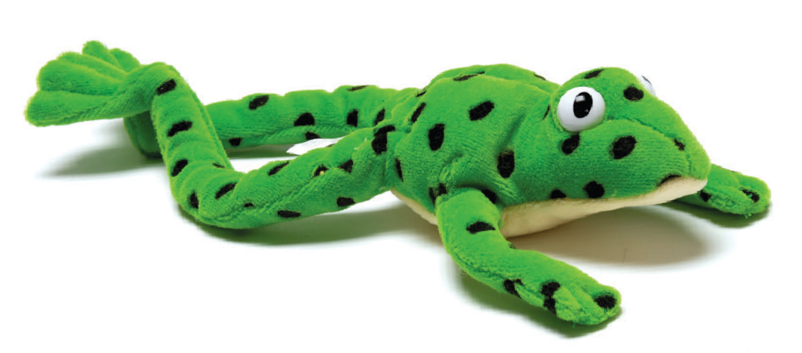

Fred says the sounds and children work out the word.

- Make up a word with three cards that your child can read quickly,
e.g. c–a–t.

Learning the Speed Sounds in the classroom.

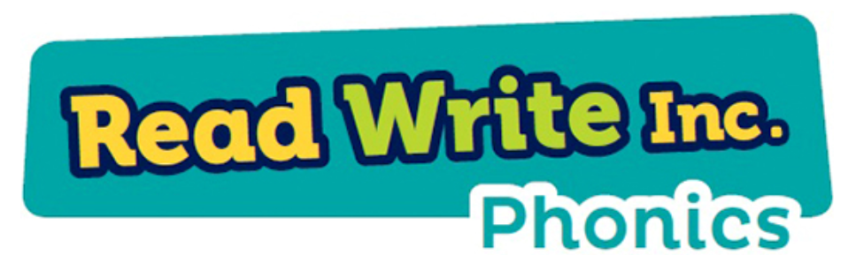
Point to and say the sounds, and then say the word. Ask your child to copy you.
Muddle up the cards. Ask your child to make the word again, and then point to and say the sounds.
Repeat with more 3-sound words, including some containing sounds made up of more than one letter, e.g. ch–a–t, sh–i–p, th–i–s.
- Put out three cards. This time, ask your child to say the sounds.
Help him or her to blend the sounds into the words, until your child can do it without your help.
- s–t–o–p, j–u–m–p, h–a–n–d, b–l–a–ck.

