Geography/History Long Term Objectives
Cycle | Year 1/2
A | Autumn | Spring | Summer
 | To Winsford and Beyond | Field to Fork | Global Village
 | Understand geographical similarities and differences through studying the human and physical geography of a small area of the United Kingdom, and of a small area in a contrasting non-European country  K Key human features, including: city, town, village,  factory, farm, house, office, port, harbour and shop  Use world maps, atlases and globes to identify the United Kingdom and its countries, as well as the countries, continents and oceans studied at this key stage  U Use aerial photographs and plan perspectives to recognise landmarks and basic human and physical features; devise a simple map; and use and construct basic symbols in a key map making of local area, birds eye view - google  Us Use simple fieldwork and observational skills to study the geography of their school and its grounds and the key human and physical features of its surrounding environment. Walk around Winsford – Story Katie in London – re write Name in Winsford.  Changes within living memory. Where appropriate, these should be used to reveal aspects of change in national life Changes from self, What was Winsford like previously?, photographs, New Town park, New houses  Events beyond living memory that are significant nationally or globally [for example, the Great Fire of London, the first aeroplane flight or events commemorated through festivals or anniversaries] What was Winsford like previously, photographs, old maps | Use basic geographical vocabulary to refer to: ▪ key physical features, including: beach, cliff, coast, forest, hill, mountain, sea, ocean, river, soil, valley, vegetation, season and weather  Events beyond living memory that are significant nationally or globally [for example, the Great Fire of London, the first aeroplane flight or events commemorated through festivals or anniversaries] (Rations, fridges) | Name and locate the world’s seven continents and five oceans  Identify seasonal and daily weather patterns in the United Kingdom and the location of hot and cold areas of the world in relation to the Equator and the North and South Poles weather reports  Use basic geographical vocabulary to refer to: ▪ key physical features, including: beach, cliff, coast, forest, hill, mountain, sea, ocean, river, soil, valley, vegetation, season and weather  Key human features, including: city, town, village, factory, farm, house, office, port, harbour and shop  Use simple compass directions (North, South, East and West) and locational and directional language [for example, near and far; left and right], to describe the location of features and routes on a map
Geography/History Long Term Objectives
Cycle | Year 1/2
B | Autumn | Spring | Summer
 | Fire Fire! | Travel, Tourism & Transport | Heroes
 | Name, locate and identify characteristics of the four countries and capital cities of the United Kingdom and its surrounding seas  Key human features, including: city, town, village, factory, farm, house, office, port, harbour and shop different types of houses and buildings  Use aerial photographs and plan perspectives to recognise landmarks and basic human and physical features; devise a simple map; and use and construct basic symbols in a key underground, bus routes  Changes within living memory. Where appropriate, these should be used to reveal aspects of change in national life What do you know about the fire service?  Events beyond living memory that are significant nationally or globally [for example, the Great Fire of London, The Queen and Royal Family  Significant historical events, people and places in their own locality. (Great Fire of Nantwich, model making) | Identify seasonal and daily weather patterns in the United Kingdom and the location of hot and cold areas of the world in relation to the Equator and the North and South Poles  Use basic geographical vocabulary to refer to: ▪ key physical features, including: beach, cliff, coast, forest, hill, mountain, sea, ocean, river, soil, valley, vegetation, season and weather  Key human features, including: city, town, village, factory, farm, house, office, port, harbour and shop  Use world maps, atlases and globes to identify the United Kingdom and its countries, as well as the countries, continents and oceans studied at this key stage  Use simple compass directions (North, South, East and West) and locational and directional language [for example, near and far; left and right], to describe the location of features and routes on a map maps and programming - beebot  Events beyond living memory that are significant nationally or globally [for example, the Great Fire of London, the first aeroplane flight, getting around from Winsford – bus, train, boat etc. | The lives of significant individuals in the past who have contributed to national and international achievements. Some should be used to compare aspects of life in different periods [for example, Elizabeth I and Queen Victoria, Christopher Columbus and Neil Armstrong, William Caxton and Tim Berners-Lee, Pieter Bruegel the Elder and LS Lowry, Rosa Parks and Emily Davison, Mary Seacole and/or Florence Nightingale and Edith Cavell Florence Nightingale, Lowry, Queens, Princess Dianna, Emily Pankhurst

Geography/History Long Term Objectives
Cycle | Year 3/4
A | Autumn | Spring | Summer
 | What makes a good leader? | Beneath our feet | The Romans
 | History  The achievements of the earliest civilizations. An overview of where and when the first civilisations appeared – Ancient Egypt  Geography  - Locate the world’s countries, using maps to focus on Europe (including the location of Russia) and North and South America, concentrating on their countries, and major cities. (KLE HAS ADDED WHENDOING SUMMER BOOKS) | Sandstone  Salt  Lion Salt Works – visit  Living things and their habitats  Electricity  Geography  - Locate the world’s countries, using maps to focus on Europe (including the location of Russia) and North and South America, concentrating on their countries, and major cities.  - Describe and understand key aspects of physical geography, including rivers, mountains, volcanoes and earthquakes, and the water cycle. - - - -  Describe and understand key aspects of human geography, including types of settlement and land use, economic activity including trade links.  - Understand geographical similarities and differences through the study of human and physical geography of a region of the United Kingdom (not local area). | British History (taught chronologically)  The Roman Empire and its impact on Britain  - Julius Caesar’s attempted invasion.  - Roman Empire and the power of its army.  - Successful invasion by Claudius and conquest, including Hadrian’s Wall.  - British resistance, e.g. Boudica  - Romanisation” of Britain

Geography/History Long Term Objectives
Cycle | Year 3/4
B | Autumn | Spring | Summer
 | Stone Age | Rainforest | Ancient Greece
 | British History (taught chronologically)  - Changes in Britain from the Stone Age to the Iron Age.  This could include:  - late Neolithic hunter-gatherers and early farmers  - Bronze Age religion, technology and travel  - Iron Age hill forts  Geography  - Understand geographical similarities and differences through the study of human and physical geography of a region of the United Kingdom (not local area).  Describe and understand key aspects of human geography, including types of settlement and land use, economic activity including trade links.  - Use the eight points of a compass, four and six-figure grid references, symbols and key (including the use of Ordnance Survey maps) to build their knowledge of the United Kingdom and the wider world. | Geography  - Locate the world’s countries, using maps to focus on Europe (including the location of Russia) and North and South America, concentrating on their countries, and major cities  - to build their knowledge of the United Kingdom and the wider world  - Locate the world’s countries, using maps to focus on Europe (including the location of Russia) and North and South America, concentrating on their environmental regions, key physical and human characteristics, countries, and major cities. | History  -Ancient Greece – a study of Greek life and achievements and their influence on the western world.  Geography  - Use the eight points of a compass, four and six-figure grid references, symbols and key (including the use of Ordnance Survey maps) to build their knowledge of the United Kingdom and the wider world.  - Use fieldwork to observe, measure and record the human and physical features in the local area using a range of methods, including sketch maps, plans and graphs, and digital technologies.  - Use fieldwork to observe, measure and record the human and physical features in the local area using a range of methods, including sketch maps, plans and graphs, and digital technologies.

Geography/History Long Term Objectives
Cycle | Year 5/6
A | Autumn | Spring | Summer
 | World War | Kings and Queens | Counties around Cheshire
 | Use maps, atlases, globes and digital/computer mapping to locate countries and describe features studied  A significant turning point in British history – WW1 and WWII.  Use dates to order and place events on a timeline.  Evaluate the usefulness of a variety of sources.  Give some reasons for some important historical events. | Use fieldwork to observe, measure and record the human and physical features in the local area using a range of methods, including sketch maps, plans and graphs, and digital technologies.  Use the eight points of a compass, four and six-figure grid references, symbols and key (including the use of Ordnance Survey maps) to build their knowledge of the United Kingdom and the wider world.  Aspect of British History that extends pupils’ chronological knowledge beyond 1066 - Changing power of monarchs using case studies.  Use dates to order and place events on a timeline  Make comparisons between aspects of periods of history and the present day  Give some reasons for some important historical events | Name and locate counties and cities of the United Kingdom, geographical regions and their key topographical features (including hills, mountains, coasts and rivers), and land-use patterns; and understand how some of these aspects have changed over time.  Describe and understand key aspects of human geography, including the distribution of natural resources including energy, food, minerals and water.  Use fieldwork to observe, measure and record the human and physical features in the local area using a range of methods, including sketch maps, plans and graphs, and digital technologies.

Geography/History Long Term Objectives
Cycle | Year 5/6
B | Autumn | Spring | Summer
 | Space | Europe (UK) | Anglo-Saxons
 | Evaluate the usefulness of a variety of sources  Construct informed responses that involve thoughtful selection and organisation of relevant historical information | Understand geographical similarities and differences through the study of human and physical geography of a region within North or South America.  Identify the position and significance of latitude, longitude, Equator, Northern Hemisphere, Southern Hemisphere, the Tropics of Cancer and Capricorn, Arctic and Antarctic Circle, the Prime/Greenwich Meridian and time zones (including day and night).  Use maps, atlases, globes and digital/computer mapping to locate countries and describe features studied  A non-European study - Mayan civilisation c.AD900 | Human geography, including; types of settlement and land use, economic activity including trade links, and the distribution of natural resources including energy, food, minerals and water.  Use the eight points of a compass, four and six-figure grid references, symbols and key (including the use of Ordnance Survey maps) to build their knowledge of the United Kingdom and the wider world.  Britain’s settlement by Anglo-Saxons and Scots.  - Scots invasions from Ireland to north Britain (now Scotland)  The Viking and Anglo-Saxon struggle for the Kingdom of England to the time of Edward the Confessor.  Use dates to order and place events on a timeline  Make comparisons between aspects of periods of history and the present day.

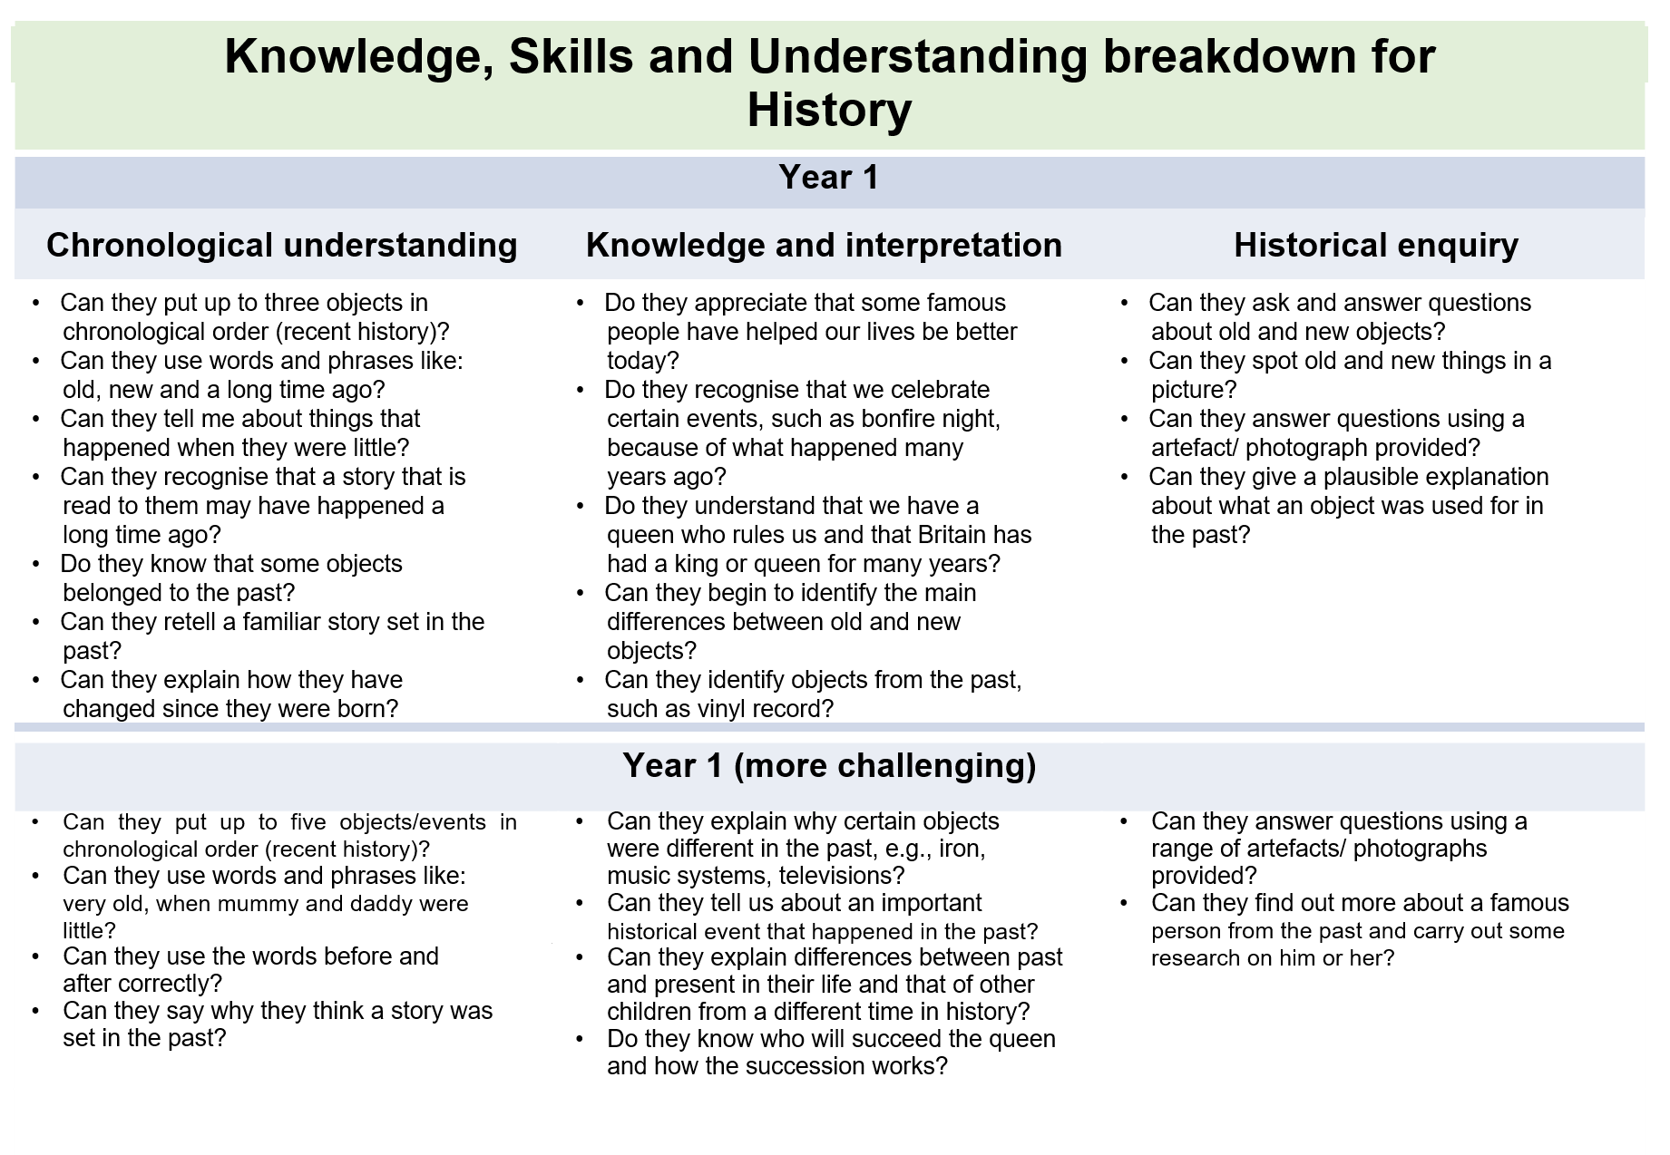
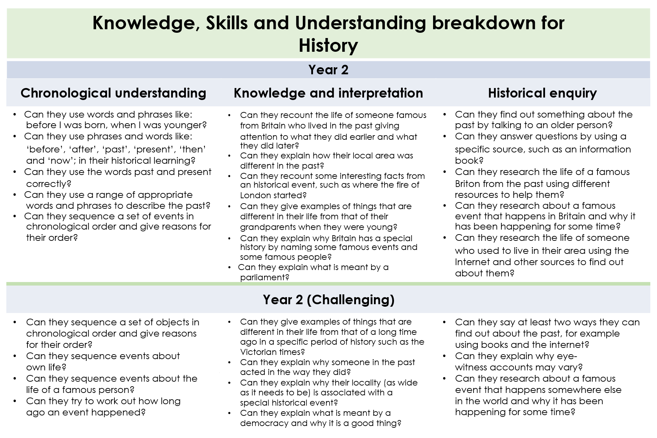
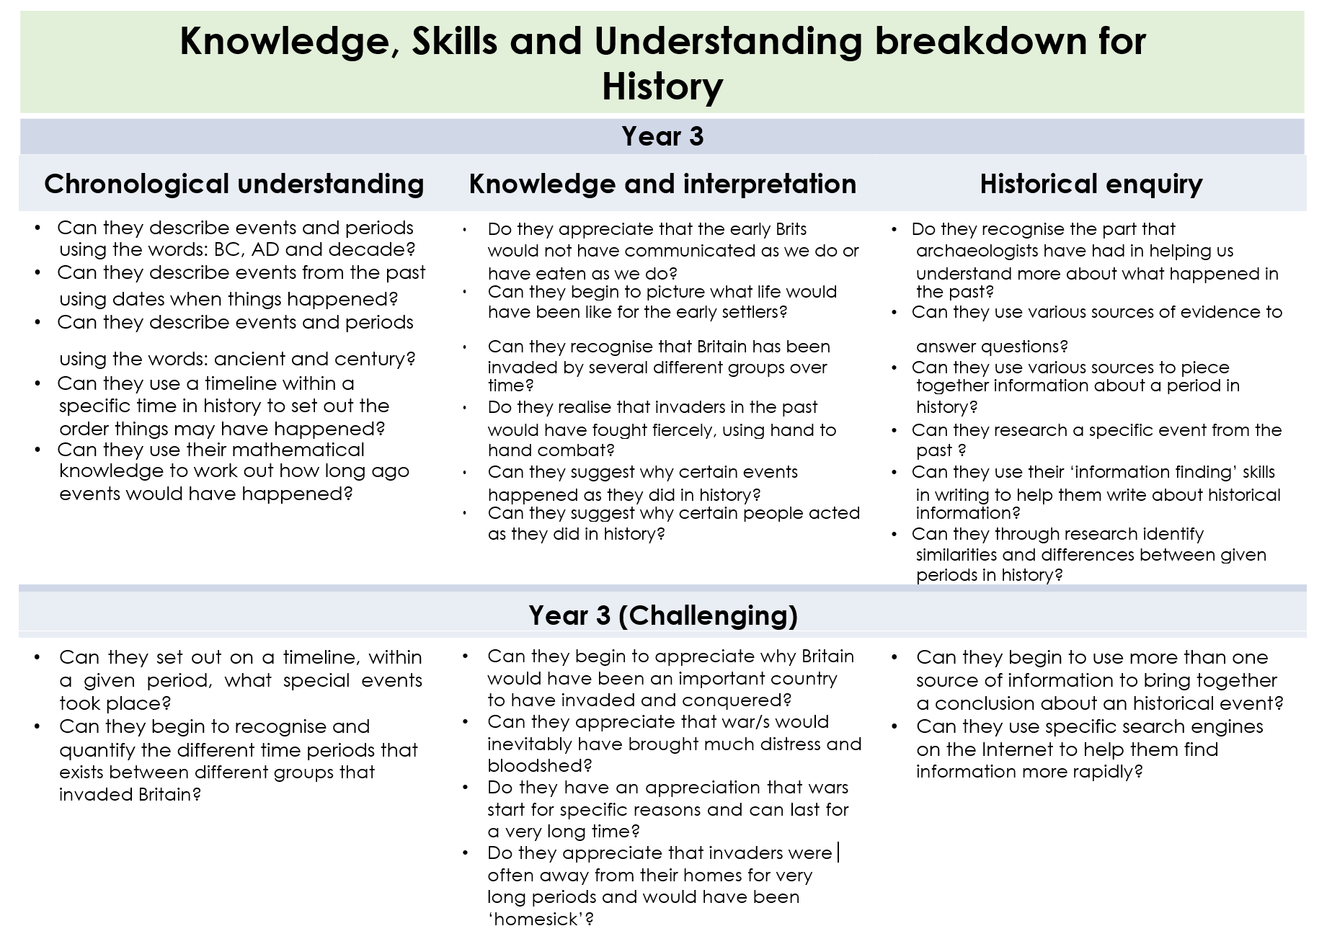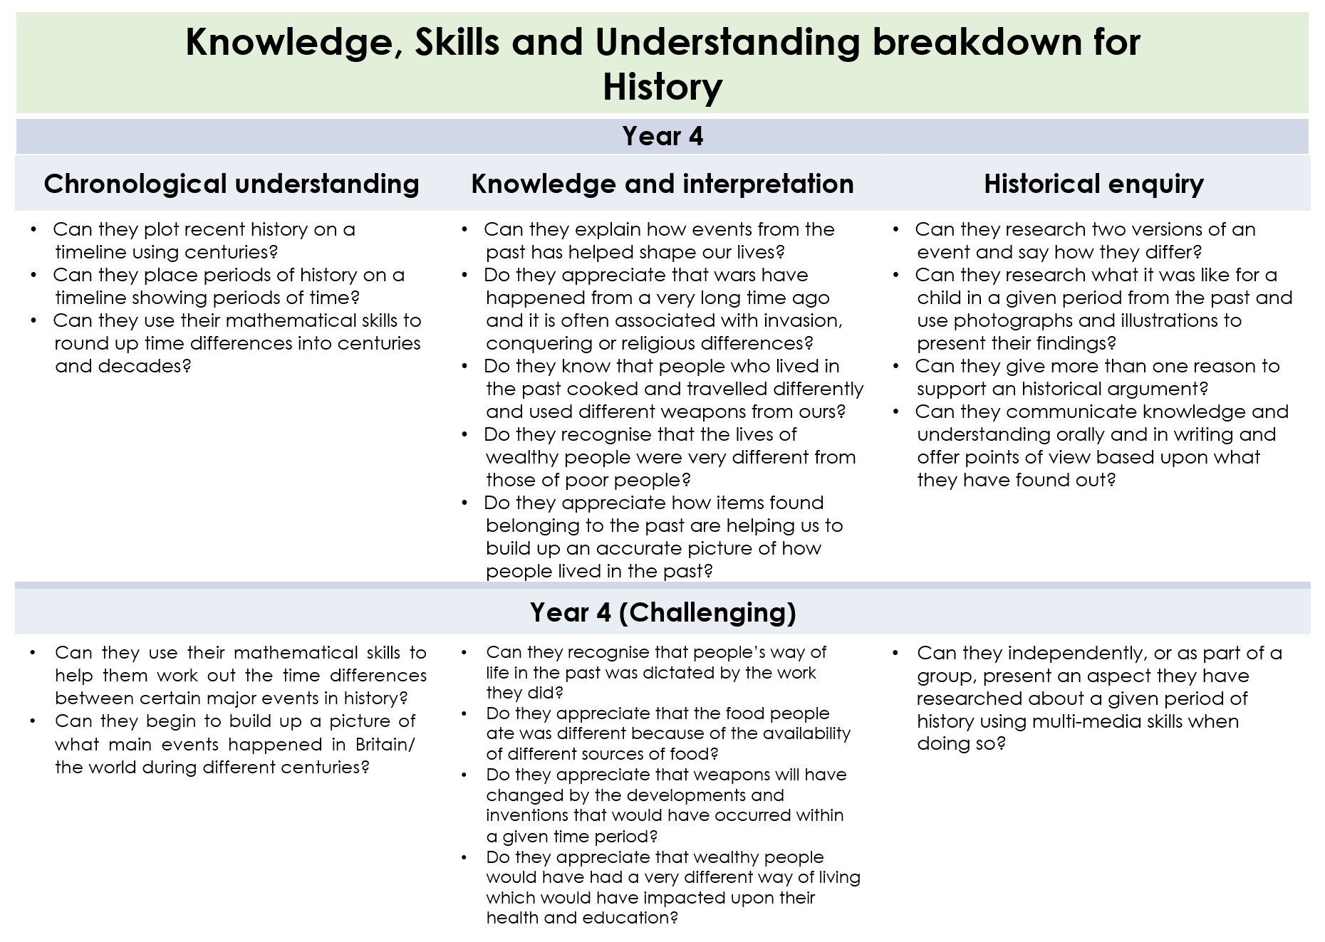
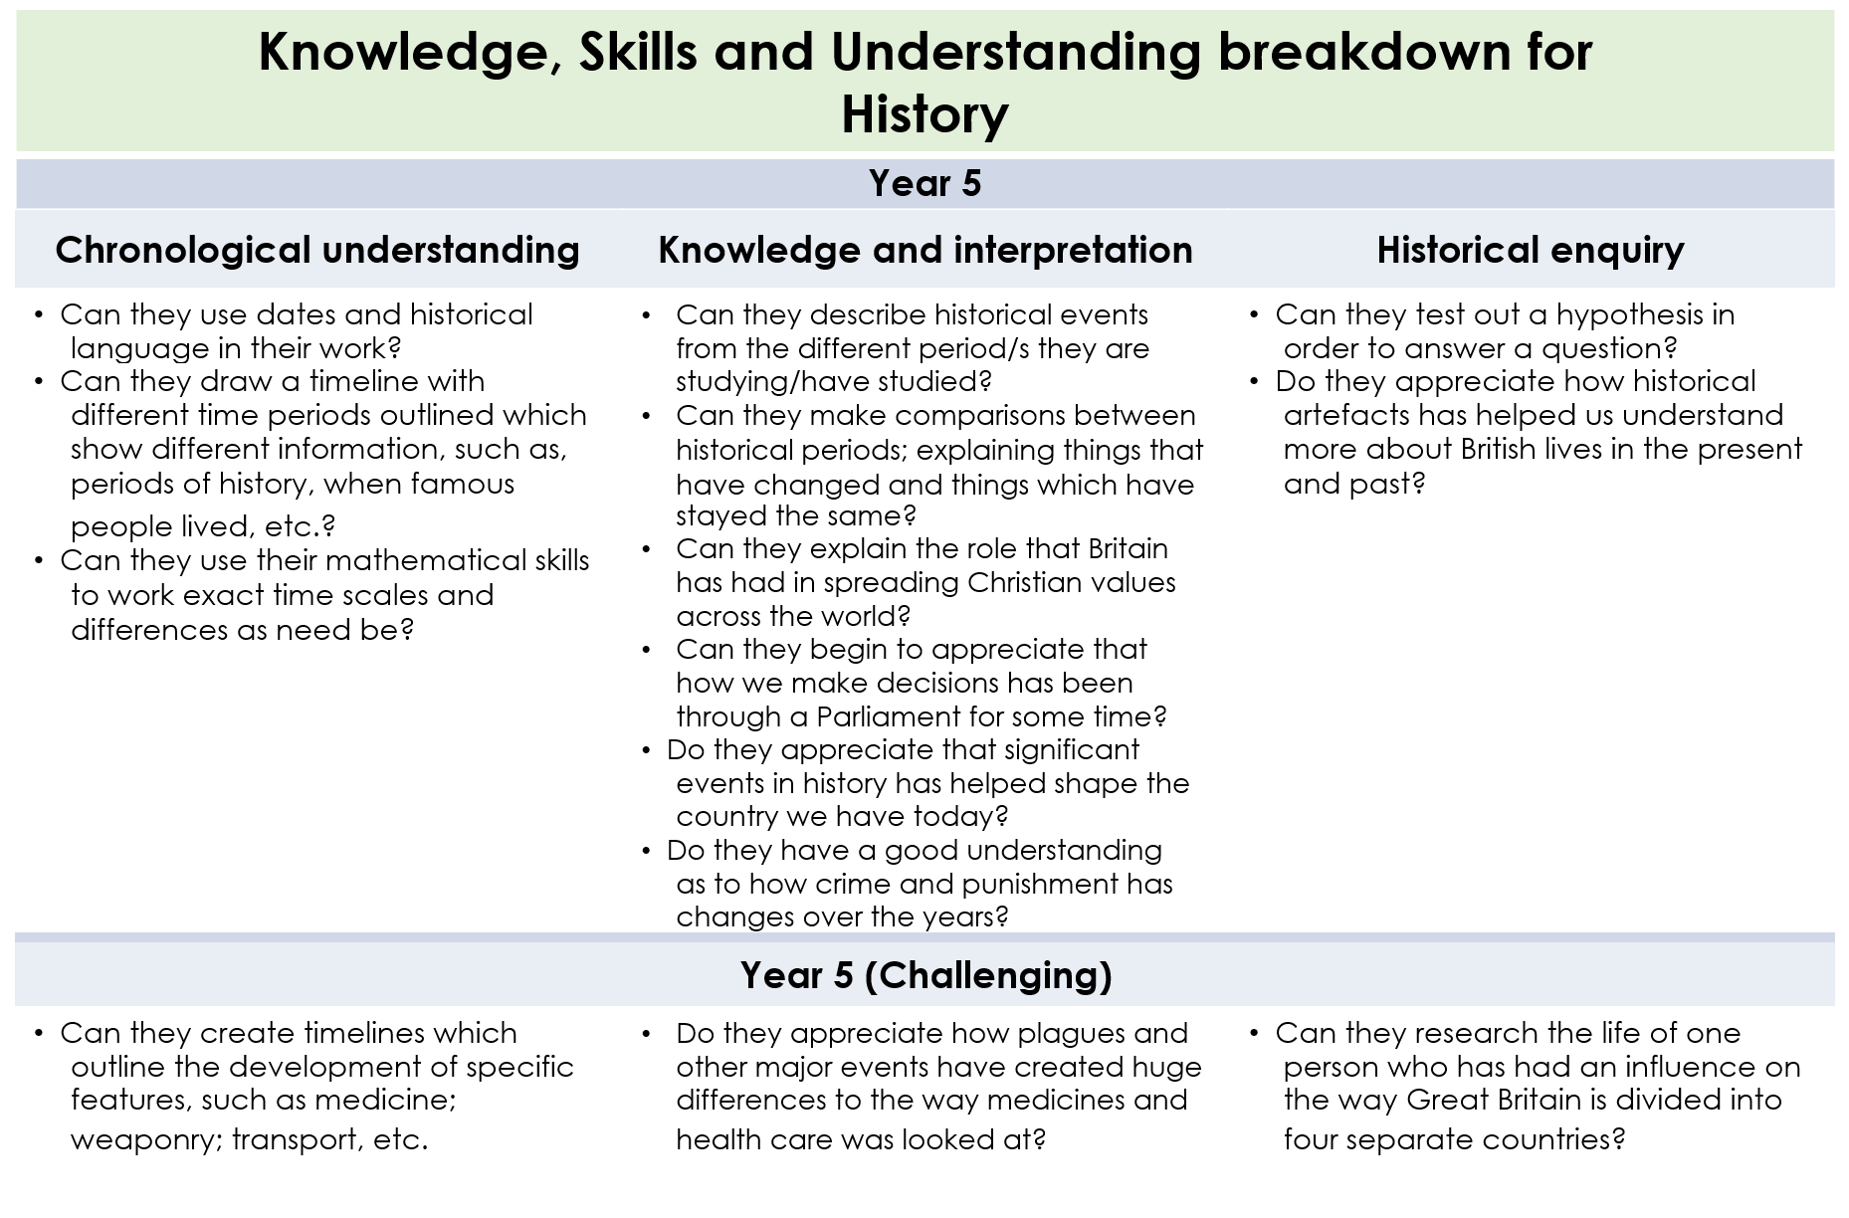
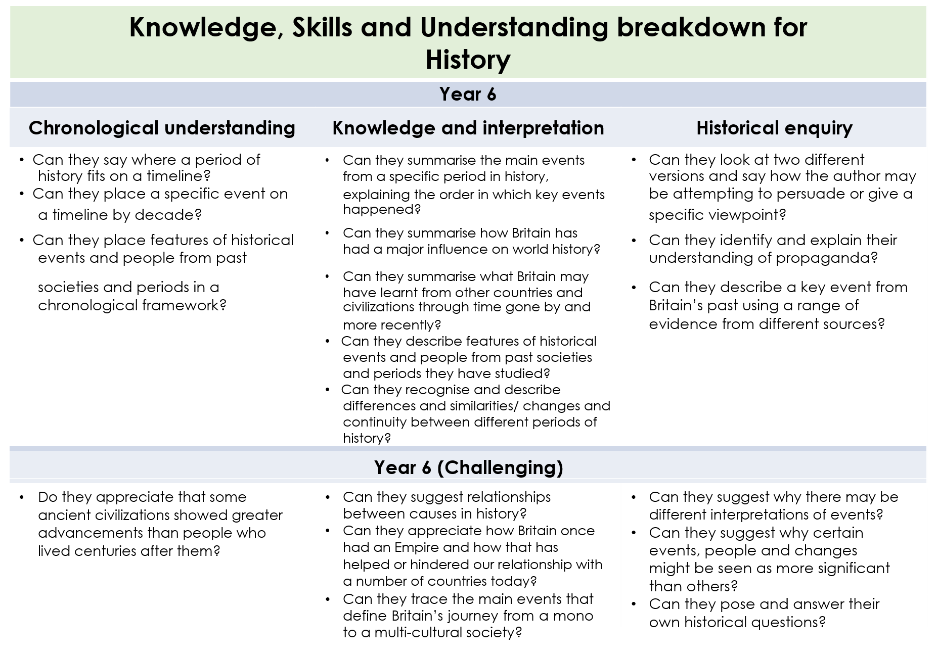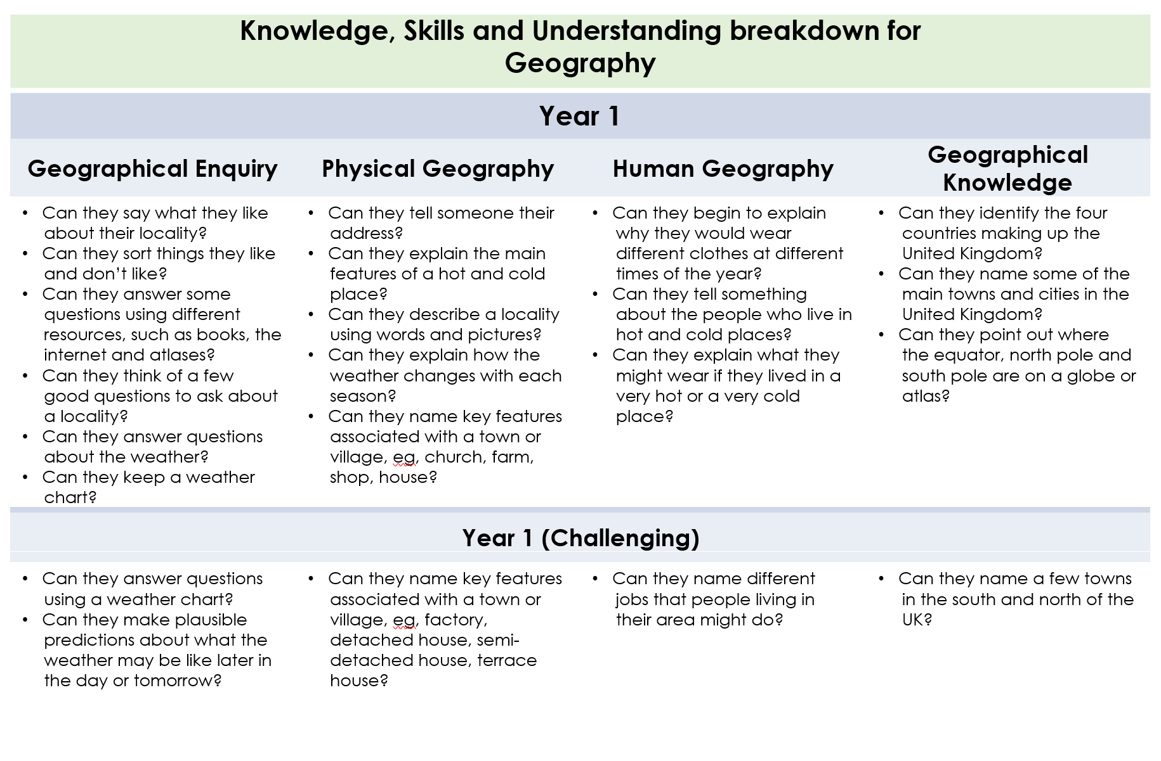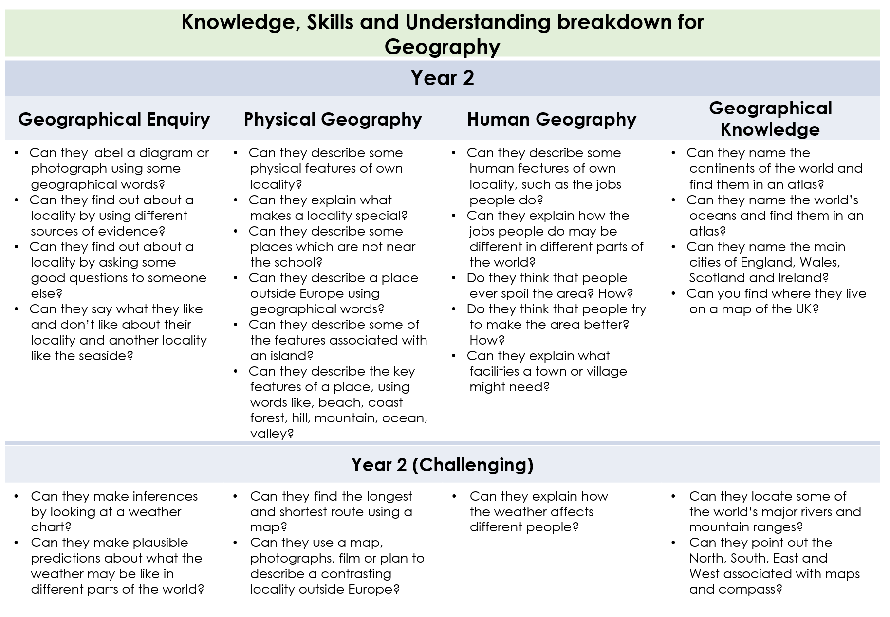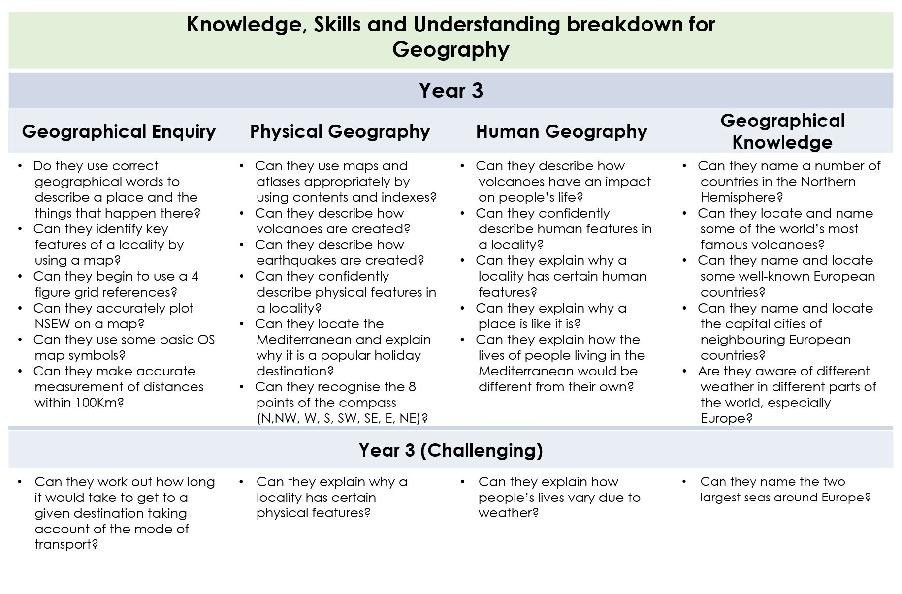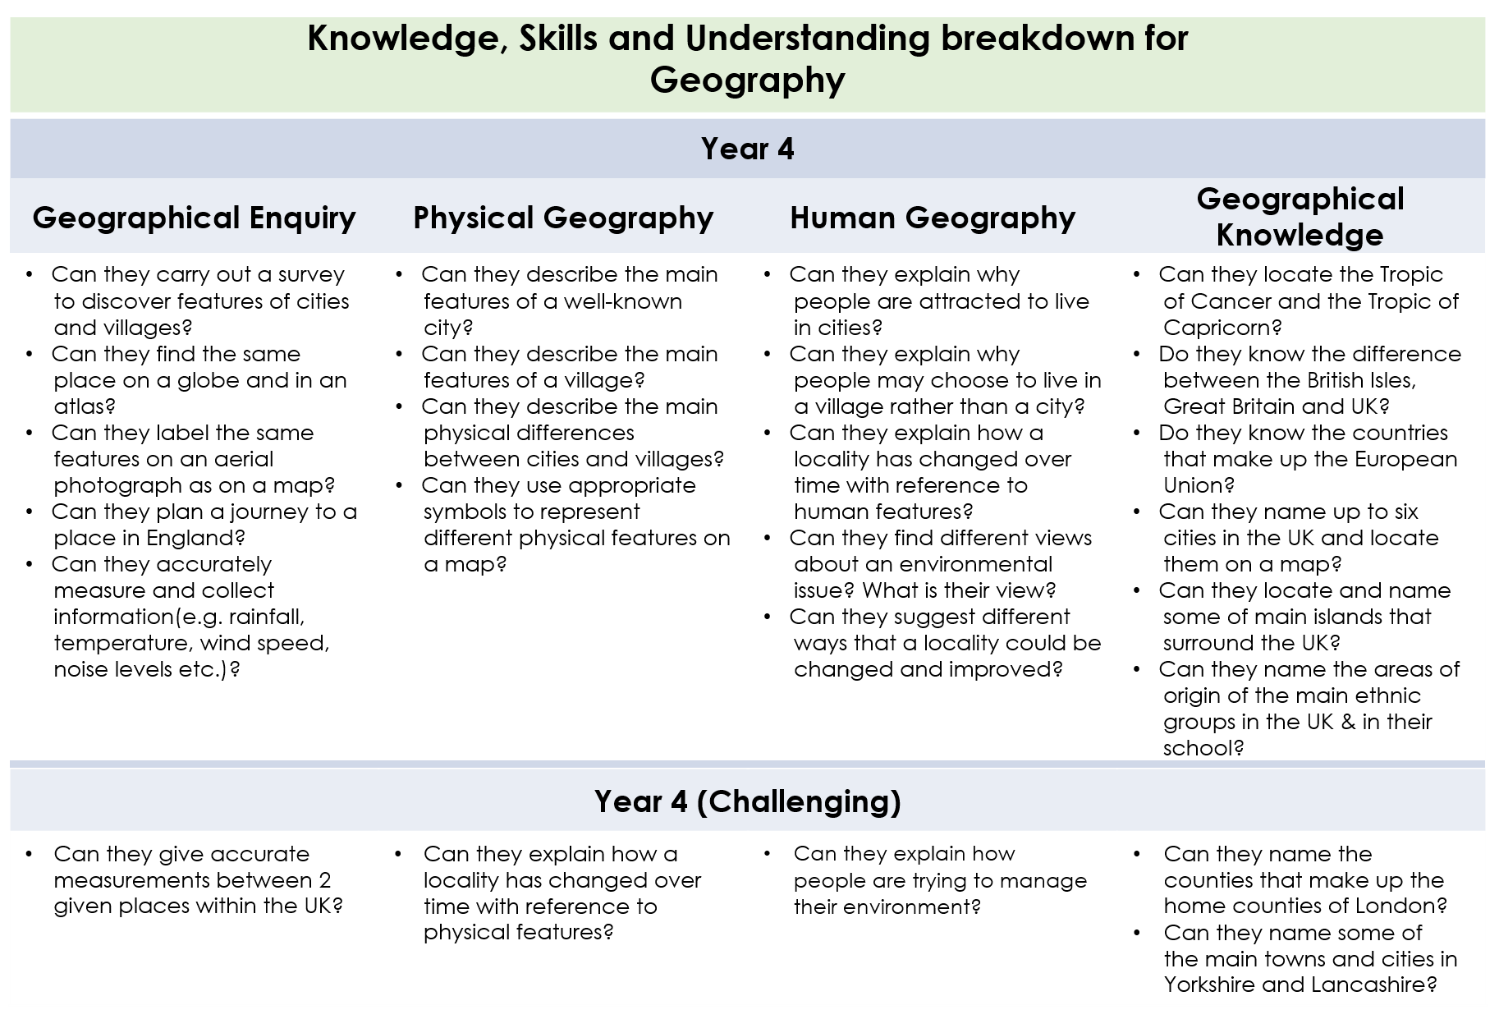
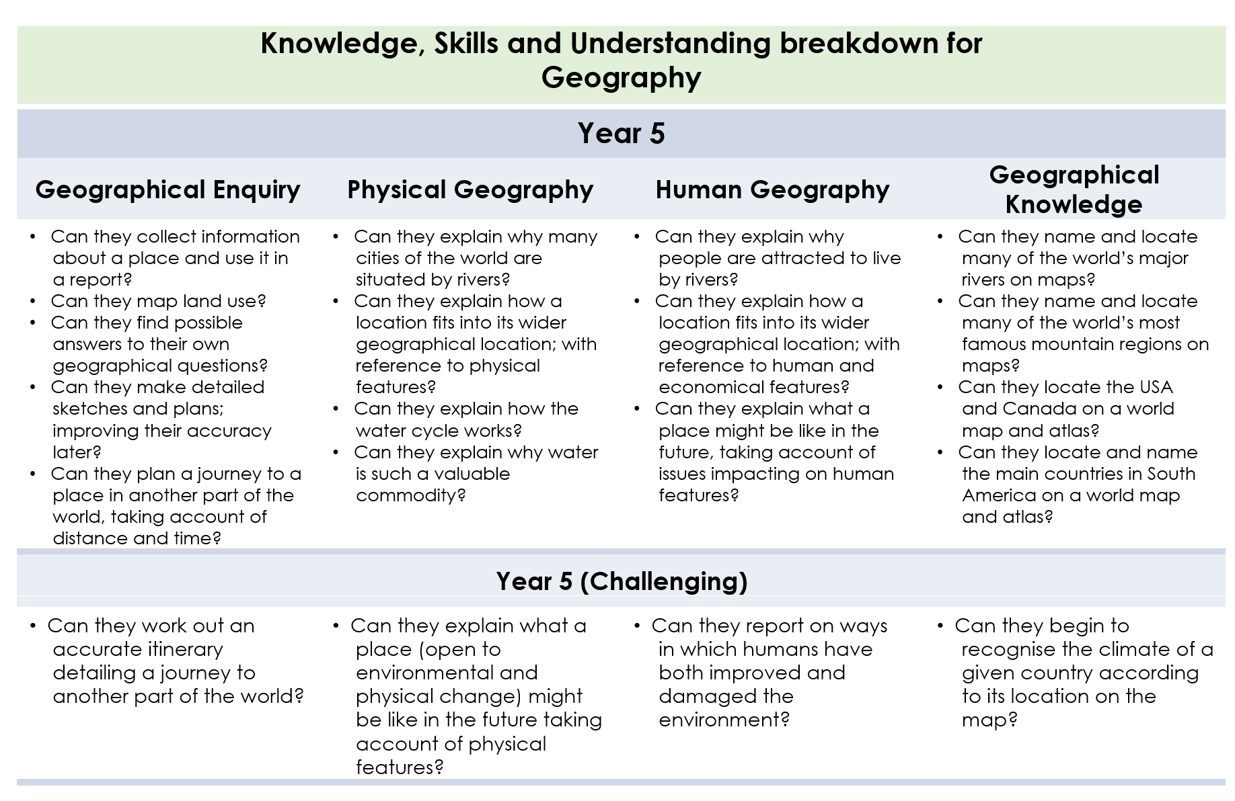
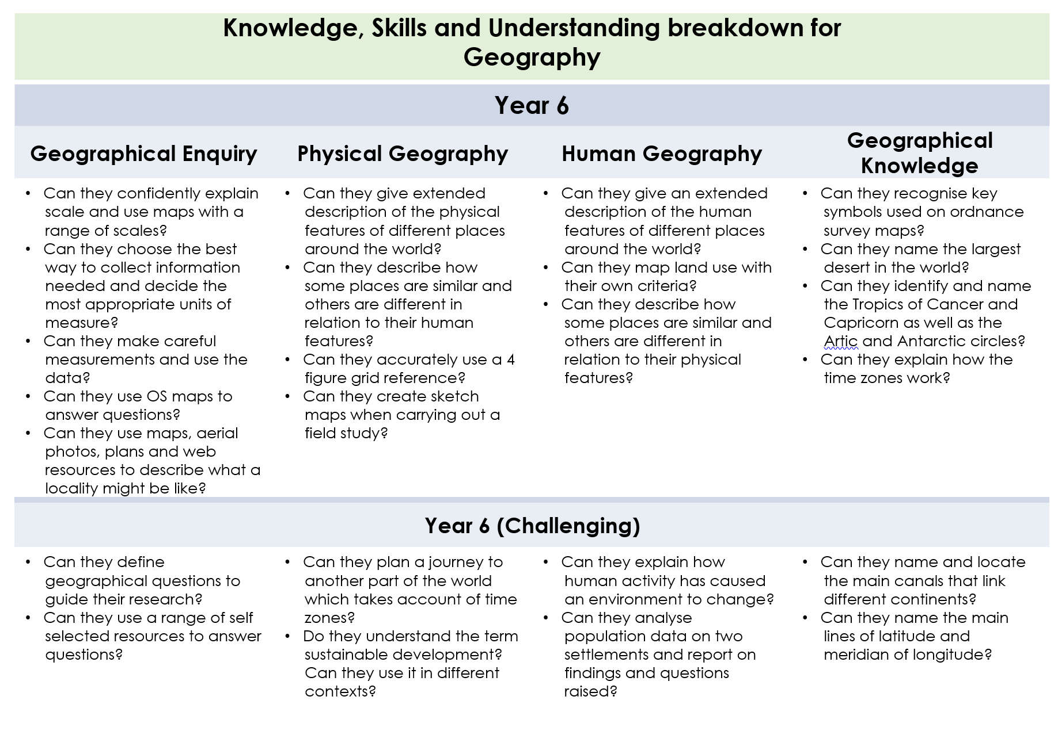
DT and Arts Long Term Objectives
Cycle | Year 1/2
A | Autumn | Spring | Summer
 | To Winsford and Beyond | Field to Fork | Global Village
- Design, make and evaluate | Mechanics  Y1 – Create products using levers and wheels.  Y2 – Crete products using winding mechanisms.  Computing  I can model designs using software.  (Make a model of Winsford/salt mine) | Electrical and electronics  Y1 – Recognise whether a battery operated device works or not.  Y2 – I can diagnose faults in battery operated devices.  Food  Y1 – Cut ingredients safely and hygienically.  Y2 - Cut, peel and grate ingredients safely and hygienically.  - Measure or weigh using measuring cups or electronic scales.  (Grow own food and use it within a cooking lesson.) | Textiles and materials  Y1 – Cut materials safely and use a range of cutting and shaping techniques.  - Shape textiles using templates  - Colour and decorate textiles.  Y2 – Measure and mark out to the nearest cm.  - Use a range of joining techniques.  - Join using a running stitch.  - Colour and decorate textiles using a range of techniques.  (Make a class rug/class tapestry.)

DT and Arts Long Term Objectives
Cycle | Year 1/2
B | Autumn | Spring | Summer
 | Fire Fire! | Travel, Tourism & Transport | Heroes
Design, make and evaluate | Food  Y1 – Cut ingredients safely and hygienically.  Y2 - Cut, peel and grate ingredients safely and hygienically.  Measure or weigh using measuring cups or electronic scales.  (Food of the time/royal dishes)  Construction  Use materials to practise drilling, screwing, gluing and nailing to make and strengthen products.  (Model of London Bridge/ Tower of London drawbridge) | Electricals and electronics  Y1 – Recognise whether a battery operated device works or not.  Y2 – I can diagnose faults in battery operated devices.  Mechanics  Y1 – Create products using levers and wheels.  Y2 – Crete products using winding mechanisms.  (Make a vehicle) | Textiles and materials  Y1 – Cut materials safely and use a range of cutting and shaping techniques.  - Shape textiles using templates  - Colour and decorate textiles.  Y2 – Measure and mark out to the nearest cm.  - Use a range of joining techniques.  - Join using a running stitch.  - Colour and decorate textiles using a range of techniques.  (Make a badge/medal)

DT and Arts Long Term Objectives
Cycle | Year 3/4
A | Autumn | Spring | Summer
 | What makes a good leader? | Beneath our feet | Cheshire
Design, make and evaluate | Textiles  Y3 – Understand the need for seam allowance.  - Join textiles using different stitches.  Y4 – Select the most appropriate techniques to decorate.  Materials  Y3 – Cut materials accurately and safely by selecting appropriate tools.  - Select appropriate joining techniques.  Y4 – Measure and mark out to the nearest mm.  - Apply appropriate cutting and shaping techniques that include cuts within the perimeter of the material.  (Link to the Egyptians – make Egyptian jewellery, name in hieroglyphics then sew names together. Make a pyramid.) | Computing  Control and monitor models using software designed for this purpose.  Electricals and electronics  Y3 – Create series circuits.  Y4 – Create parallel circuits. | Food  Y3 – Prepare ingredients hygienically using appropriate utensils.  - Measure accurately.  - Follow a recipe and assemble or cook ingredients.  Y4 - Prepare ingredients hygienically using appropriate utensils.  - Measure ingredients to the nearest gram.  - Assemble and cook ingredients – controlling the temperature of the oven or hob.  Construction and mechanics  Y3 – Use suitable techniques to construct products or to repair items.  - Use scientific knowledge of the transference of forces to choose appropriate mechanisms for a product.  Y4 – Strengthen materials using suitable techniques.  - Use scientific knowledge of the transference of forces to choose appropriate mechanisms for a product.  (Use local products to cook. Explore Roman food – make pizza/pasta? Grow own herbs to use within cooking.)

DT and Arts Long Term Objectives
Cycle | Year 3/4
B | Autumn | Spring | Summer
 | Stone Age | Rainforest | Vikings
Design, make and evaluate | Textiles  Y3 – Understand the need for seam allowance.  - Join textiles using different stitches.  Y4 – Select the most appropriate techniques to decorate.  Materials  Y3 – Cut materials accurately and safely by selecting appropriate tools.  - Select appropriate joining techniques.  Y4 – Measure and mark out to the nearest mm.  - Apply appropriate cutting and shaping techniques that include cuts within the perimeter of the material. | Food  Y3 – Prepare ingredients hygienically using appropriate utensils.  - Measure accurately.  - Follow a recipe and assemble or cook ingredients.  Y4 - Prepare ingredients hygienically using appropriate utensils.  - Measure ingredients to the nearest gram.  - Assemble and cook ingredients – controlling the temperature of the oven or hob.  (Create Rainforest jam or a rainforest smoothie.)  Computing  Control and monitor models using software designed for this purpose. | Construction and mechanics  Y3 – Use suitable techniques to construct products or to repair items.  - Use scientific knowledge of the transference of forces to choose appropriate mechanisms for a product.  Y4 – Strengthen materials using suitable techniques.  - Use scientific knowledge of the transference of forces to choose appropriate mechanisms for a product.  (Make a Viking long boat.)  Electricals and electronics  Y3 – Create series circuits.  Y4 – Create parallel circuits.

DT and Arts Long Term Objectives
Cycle | Year 5/6
A | Autumn | Spring | Summer
 | World War | Kings and Queens | Counties around Cheshire
Design, make and evaluate | Food  Y5 – Understand the correct storage and handling of ingredients.  - Demonstrate a range of baking and cooking techniques.  Y6 – Measure accurately and calculate ratios of ingredients to scale up or down from a recipe.  - I can create and refine recipes, including ingredients, methods, cooking times and temperatures.  (War-time recipes)  Electrical and electronics  Y5 – Create circuits using electronic kits that employ a number of components.  Y6 - Create circuits using electronic kits that employ a number of components with increasing confidence.  (Make an alarm system with either light and/or sound.) | Textiles  Y5 – Create objects (such as a cushion) that employ seam allowance.  - Join textiles with a combination of stitching techniques (e.g. back stitch for seams and running stitch to attach decoration.)  Y6 – Use the qualities of materials to create suitable visual and tactile effects in the decoration of textiles.  (Make a royal cushion)  Construction and mechanics  Develop a range of practical skills to create products.  Y5 – Convert rotary motion to linear using cams.  Y6 – Use innovative combinations of electronics and mechanic in product designs.  (Make a sword/model) | Materials  Y5 – Cut materials with precision and refine the finish with appropriate tools.  Y6 – Show understanding of the quality of materials to choose the appropriate tools to cut and shape.  Computing  Write code to control and monitor models or products.

DT Long Term Objectives
Cycle | Year 5/6
B | Autumn | Spring | Summer
 | Space | Europe (UK) | Anglo-Saxons
Design, make and evaluate | Electrical and electronics  Y5 – Create circuits using electronic kits that employ a number of components.  Y6 - Create circuits using electronic kits that employ a number of components with increasing confidence.  Construction and mechanics  Develop a range of practical skills to create products.  Y5 – Convert rotary motion to linear using cams.  Y6 – Use innovative combinations of electronics and mechanic in product designs. | Food  Y5 – Understand the correct storage and handling of ingredients.  - Demonstrate a range of baking and cooking techniques.  Y6 – Measure accurately and calculate ratios of ingredients to scale up or down from a recipe.  - I can create and refine recipes, including ingredients, methods, cooking times and temperatures.  Computing  Write code to control and monitor models or products. | Textiles  Y5 – Create objects (such as a cushion) that employ seam allowance.  - Join textiles with a combination of stitching techniques (e.g. back stitch for seams and running stitch to attach decoration.)  Y6 – Use the qualities of materials to create suitable visual and tactile effects in the decoration of textiles.  Materials  Y5 – Cut materials with precision and refine the finish with appropriate tools.  Y6 – Show understanding of the quality of materials to choose the appropriate tools to cut and shape.
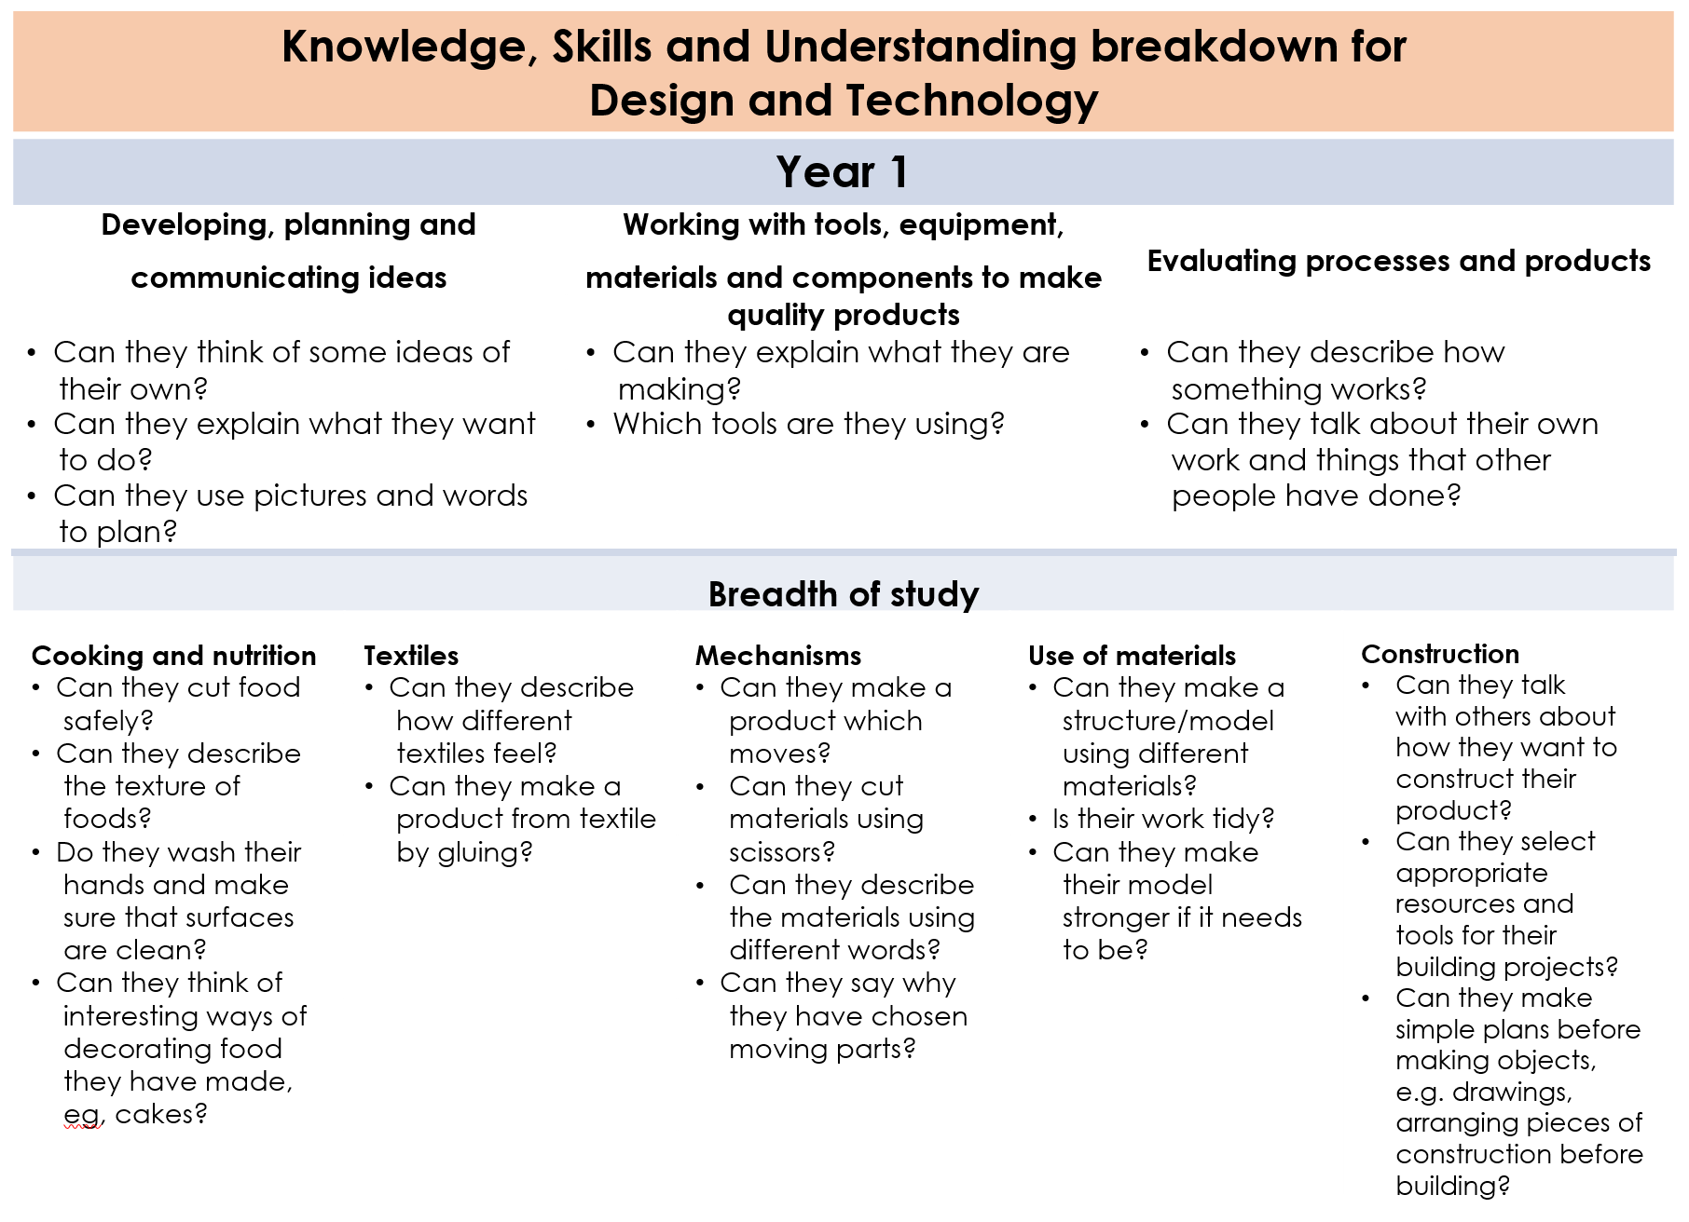
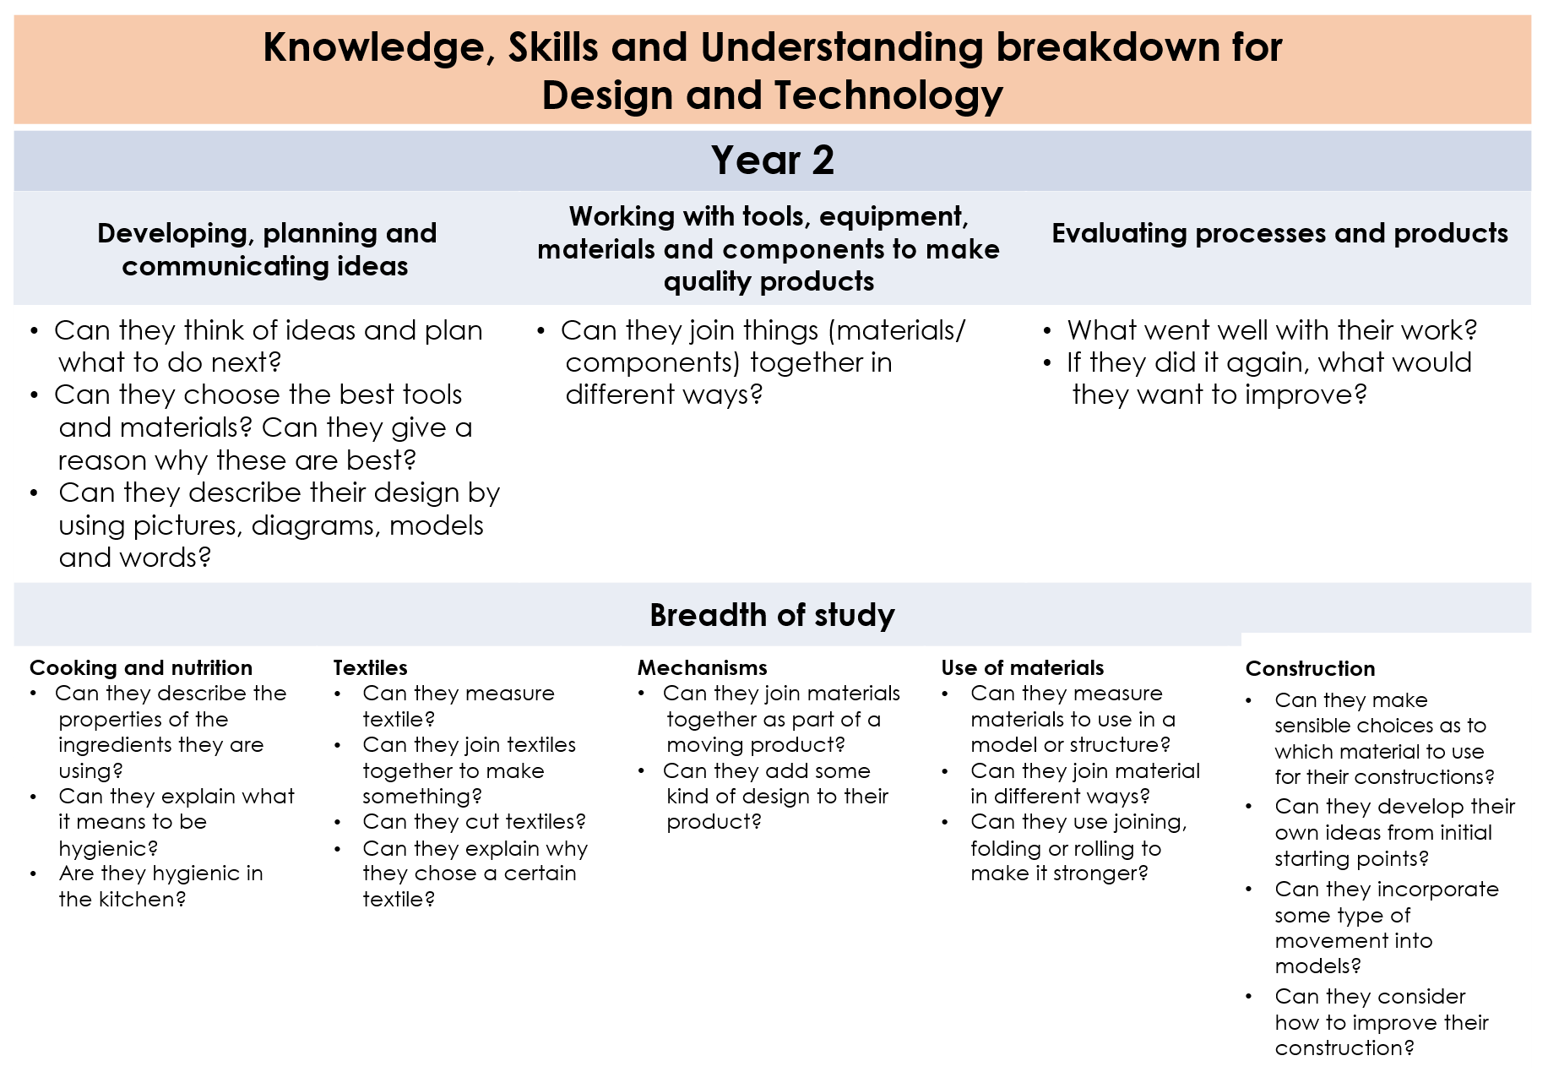
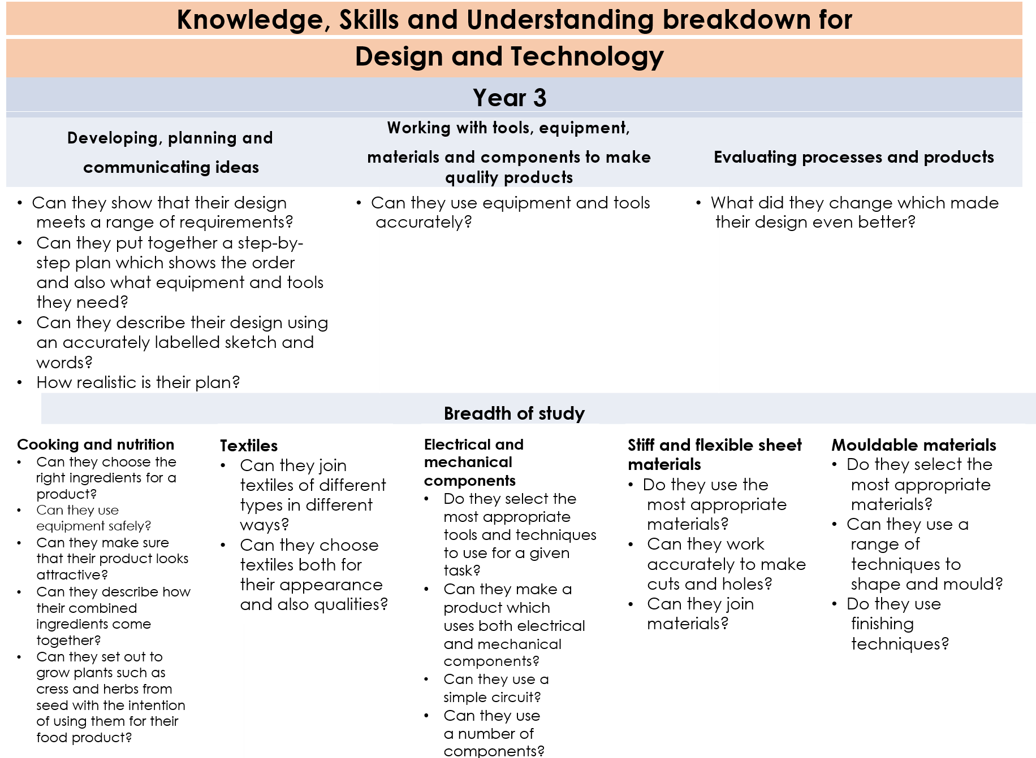
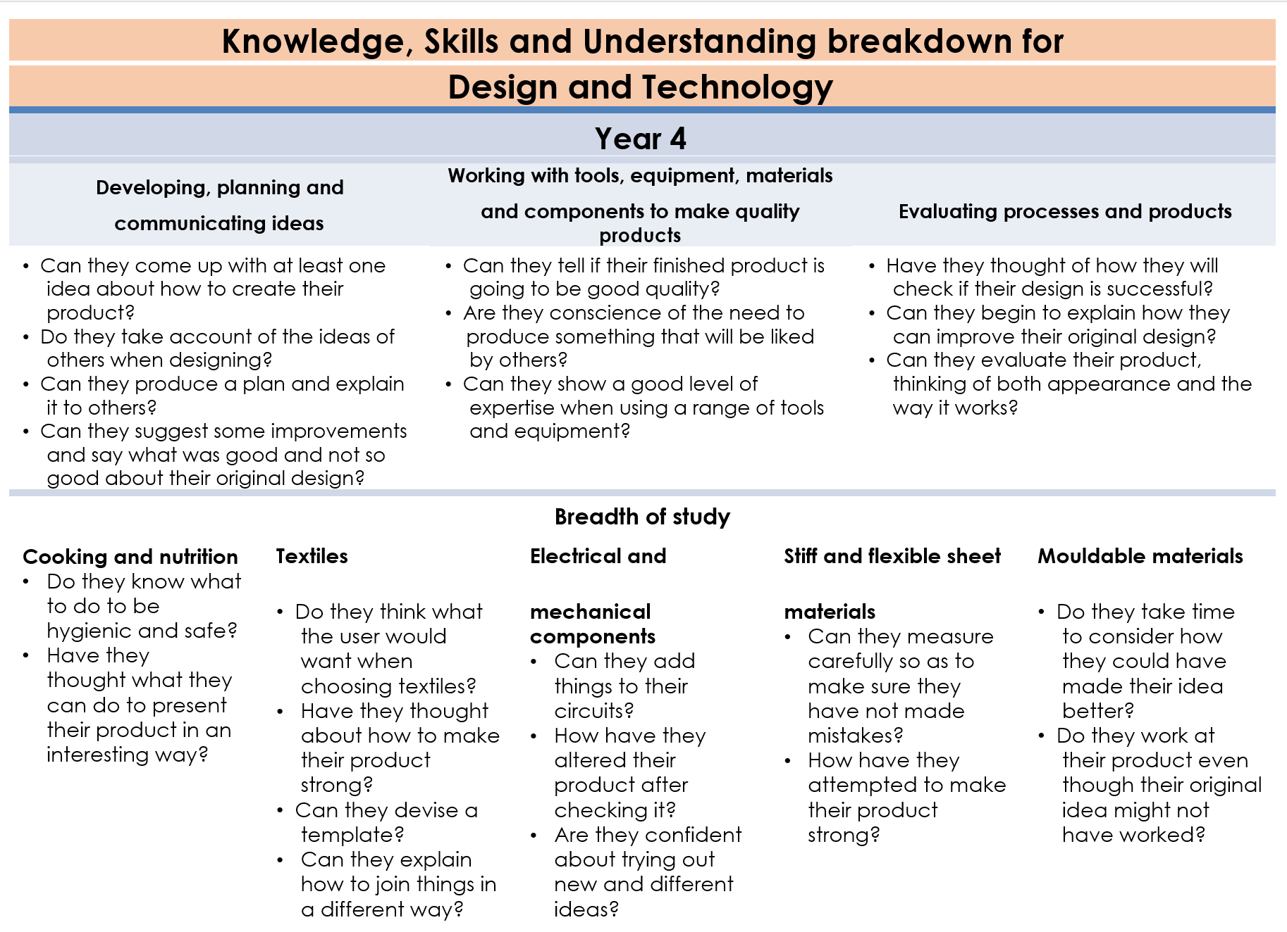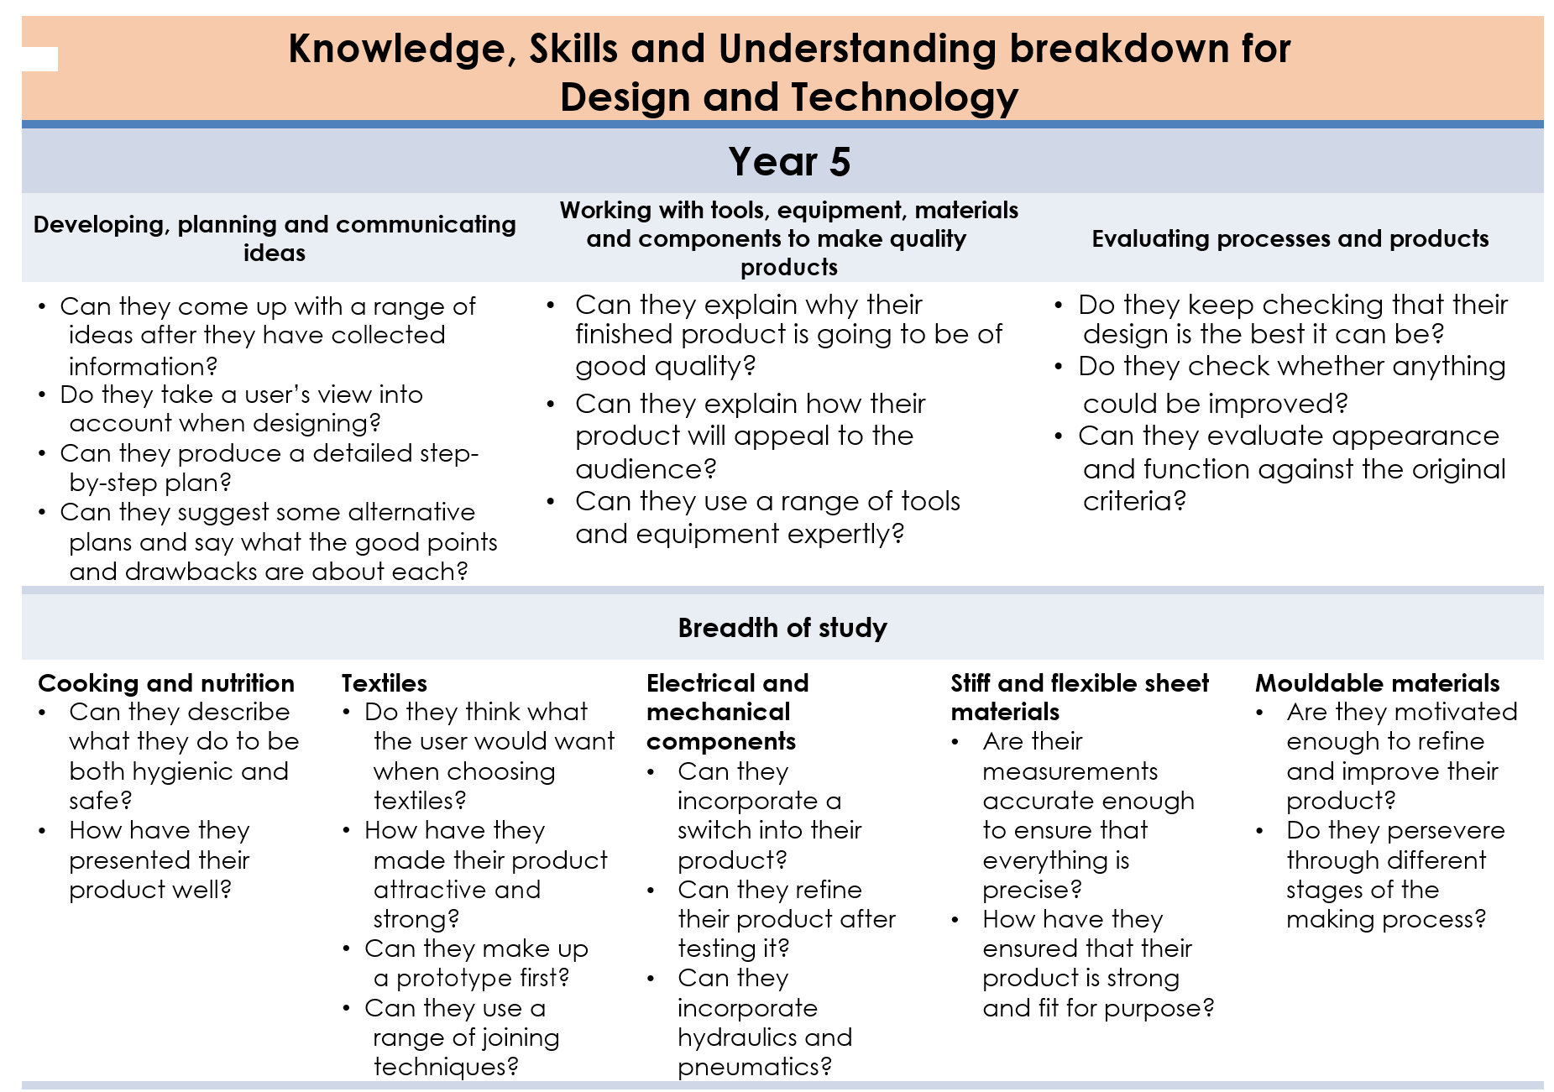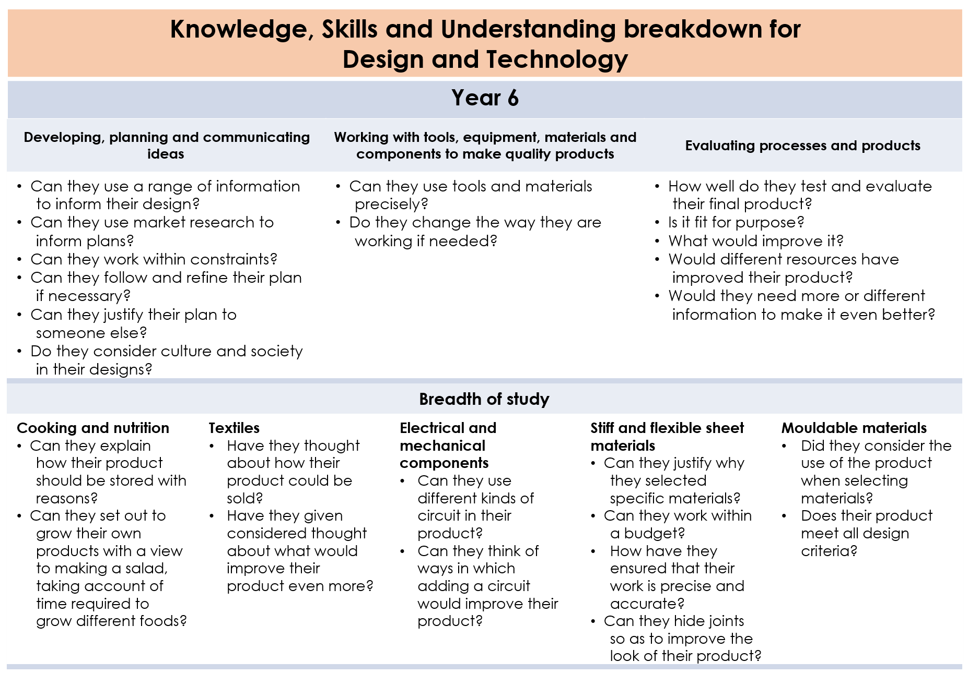
The Arts Long Term Objectives
Cycle | Year 1/2
A | Autumn | Spring | Summer
 | To Winsford and Beyond | Field to Fork | Global Village
 | Drawing  Year 1: Use a variety of tools, inc. pencils, rubbers, crayons, pastels, felt tips, charcoal, ballpoints, chalk and other dry media. Use a sketchbook to gather and collect artwork. Begin to explore the use of line, shape and colour  Year 2: Layer different media, e.g. crayons, pastels, felt tips, charcoal and ballpoint. Understand the basic use of a sketchbook and work out ideas for drawings. Draw for a sustained period of time from the figure and real objects, including single and grouped objects. Experiment with the visual elements; line, shape, pattern and colour.  Dance  Music – Music Express | Painting  Year 1: Use a variety of tools and techniques including the use of different brush sizes and types. Mix and match colours to artefacts and objects. Work on different scales. Mix secondary colours and shades using different types of paint. Create different textures e.g. use of sawdust.  Year 2: Mix a range of secondary colours, shades and tones. Experiment with tools and techniques, inc. layering, mixing media, scraping through etc. Name different types of paint and their properties. Work on a range of scales e.g. large brush on large paper etc. Mix and match colours using artefacts and objects.  Printing:  Year 1: Make marks in print with a variety of objects, including natural and made objects. Carry out different printing techniques e.g. monoprint, block, relief and resist printing. Make rubbings. Build a repeating pattern and recognise pattern in the environment.  Year 2: Use a variety of techniques, inc. carbon printing, relief, press and fabric printing and rubbings. Design patterns of increasing complexity and repetition. Print using a variety of materials, objects and techniques.  Dance  Music – Music Express | Textiles/collage  Year 1: Use a variety of techniques, e.g. weaving, finger knitting, fabric crayons, sewing and binca. How to thread a needle, cut, glue and trim material. Create images from imagination, experience or observation. Use a wide variety of media, inc. photocopied material, fabric, plastic, tissue, magazines, crepe paper, etc.  Year 2: Use a variety of techniques, inc. weaving, French knitting, tiedyeing, fabric crayons and wax or oil resist, appliqué and embroidery. Create textured collages from a variety of media. Make a simple mosaic. Stitch, knot and use other manipulative skills.  3D form  Year 1: Manipulate clay in a variety of ways, e.g. rolling, kneading and shaping. Explore sculpture with a range of malleable media, especially clay. Experiment with, construct and join recycled, natural and man-made materials. Explore shape and form.  Year 2:  Manipulate clay for a variety of purposes, inc. thumb pots, simple coil pots and models. Build a textured relief tile. Understand the safety and basic care of materials and tools. Experiment with, construct and join recycled, natural and man-made materials more confidently.  Dance  Music – Music Express

The Arts Long Term Objectives
Cycle | Year 1/2
B | Autumn | Spring | Summer
 | Fire Fire! | Travel, Tourism & Transport | Heroes
 | Painting  Year 1: Use a variety of tools and techniques including the use of different brush sizes and types. Mix and match colours to artefacts and objects. Work on different scales. Mix secondary colours and shades using different types of paint. Create different textures e.g. use of sawdust.  Year 2: Mix a range of secondary colours, shades and tones. Experiment with tools and techniques, inc. layering, mixing media, scraping through etc. Name different types of paint and their properties. Work on a range of scales e.g. large brush on large paper etc. Mix and match colours using artefacts and objects.  Printing:  Year 1: Make marks in print with a variety of objects, including natural and made objects. Carry out different printing techniques e.g. monoprint, block, relief and resist printing. Make rubbings. Build a repeating pattern and recognise pattern in the environment.  Year 2: Use a variety of techniques, inc. carbon printing, relief, press and fabric printing and rubbings. Design patterns of increasing complexity and repetition. Print using a variety of materials, objects and techniques.  Dance  Music – Music Express | Drawing  Year 1: Use a variety of tools, inc. pencils, rubbers, crayons, pastels, felt tips, charcoal, ballpoints, chalk and other dry media. Use a sketchbook to gather and collect artwork. Begin to explore the use of line, shape and colour  Year 2: Layer different media, e.g. crayons, pastels, felt tips, charcoal and ballpoint. Understand the basic use of a sketchbook and work out ideas for drawings. Draw for a sustained period of time from the figure and real objects, including single and grouped objects. Experiment with the visual elements; line, shape, pattern and colour.  3D form  Year 1: Manipulate clay in a variety of ways, e.g. rolling, kneading and shaping. Explore sculpture with a range of malleable media, especially clay. Experiment with, construct and join recycled, natural and man-made materials. Explore shape and form.  Year 2:  Manipulate clay for a variety of purposes, inc. thumb pots, simple coil pots and models. Build a textured relief tile. Understand the safety and basic care of materials and tools. Experiment with, construct and join recycled, natural and man-made materials more confidently.  Dance  Music – Music Express | Textiles/collage  Year 1: Use a variety of techniques, e.g. weaving, finger knitting, fabric crayons, sewing and binca. How to thread a needle, cut, glue and trim material. Create images from imagination, experience or observation. Use a wide variety of media, inc. photocopied material, fabric, plastic, tissue, magazines, crepe paper, etc.  Year 2: Use a variety of techniques, inc. weaving, French knitting, tiedyeing, fabric crayons and wax or oil resist, appliqué and embroidery. Create textured collages from a variety of media. Make a simple mosaic. Stitch, knot and use other manipulative skills.  Dance  Music – Music Express

The Arts Long Term Objectives
Cycle | Year 3/4
A | Autumn | Spring | Summer
 | What makes a good leader? | Beneath our feet | Cheshire
 | Textiles/collage  Year 3: Use a variety of techniques, inc. printing, dying, quilting, weaving, embroidery, paper and plastic trappings and appliqué. Name the tools and materials they have used. Develop skills in stitching. Cutting and joining. Experiment with a range of media e.g. overlapping, layering etc.  Year 4: Match the tool to the material. Combine skills more readily. Choose collage or textiles as a means of extending work already achieved. Refine and alter ideas and explain choices using an art vocabulary. Collect visual information from a variety of sources, describing with vocabulary based on the visual and tactile elements. Experiments with paste resist.  Dance  Music – Music Express | Painting:  Year 3: Minx a variety of colours and know which primary colours make secondary colours. Use a developed colour vocabulary. Experiment with different effects and textures inc. blocking in colour, washes, thickened paint etc. Work confidently on a range of scales e.g. thin brush on small picture etc.  Year 4: Make a match colours with increasing accuracy. Use more specific colour language e.g. tint, tone, shade, hue. Choose paints and implements appropriately. Plan and create different effects and textures with paint according to what they need for the task. Show increasing independence and creativity with the painting process.  Printing:  Year 3: Print using a variety of materials, objects and techniques including layering. Talk about the processes used to produce a simple print. To explore pattern and shape, creating designs for printing.  Year 4: Research, create and refine a print using a variety of techniques. Select broadly the kinds of material to print with in order to get the effect they want. Resist printing including marbling, silkscreen and coldwater paste.  Dance  Music – Music Express | Drawing  Year 3: Experiment with different grades of pencil and other implements. Plan, refine and alter their drawings as necessary. Use their sketchbook to collect and record visual information from different sources. Draw for a sustained period of time at their own level. Use different media to achieve variations in line, texture, tone, colour, shape and pattern.  Year 4: Make informed choices in drawing inc. paper and media. Alter and refine drawings and describe changes using art vocabulary. Collect images and information independently in a sketchbook. Use research to inspire drawings from memory and imagination. Explore relationships between line and tone, pattern and shape, line and texture.  3D form  Year 3: Join clay adequately and work reasonably independently. Construct a simple clay base for extending and modelling other shapes. Cut and join wood safely and effectively. Make a simple papier mache object. Plan, design and make models.  Year 4: Make informed choices about the 3D technique chosen. Show an understanding of shape, space and form. Plan, design, make and adapt models. Talk about their work understanding that it has been sculpted, modelled or constructed. Use a variety of materials.  Dance  Music – Music Express

The Arts Long Term Objectives
Cycle | Year 3/4
B | Autumn | Spring | Summer
 | Stone Age | Rainforest | Vikings
 | Textiles/collage  Year 3: Use a variety of techniques, inc. printing, dying, quilting, weaving, embroidery, paper and plastic trappings and appliqué. Name the tools and materials they have used. Develop skills in stitching. Cutting and joining. Experiment with a range of media e.g. overlapping, layering etc.  Year 4: Match the tool to the material. Combine skills more readily. Choose collage or textiles as a means of extending work already achieved. Refine and alter ideas and explain choices using an art vocabulary. Collect visual information from a variety of sources, describing with vocabulary based on the visual and tactile elements. Experiments with paste resist.  Drawing  Year 3: Experiment with different grades of pencil and other implements. Plan, refine and alter their drawings as necessary. Use their sketchbook to collect and record visual information from different sources. Draw for a sustained period of time at their own level. Use different media to achieve variations in line, texture, tone, colour, shape and pattern.  Year 4: Make informed choices in drawing inc. paper and media. Alter and refine drawings and describe changes using art vocabulary. Collect images and information independently in a sketchbook. Use research to inspire drawings from memory and imagination. Explore relationships between line and tone, pattern and shape, line and texture.  Dance  Music – Music Express | Painting:  Year 3: Minx a variety of colours and know which primary colours make secondary colours. Use a developed colour vocabulary. Experiment with different effects and textures inc. blocking in colour, washes, thickened paint etc. Work confidently on a range of scales e.g. thin brush on small picture etc.  Year 4: Make a match colours with increasing accuracy. Use more specific colour language e.g. tint, tone, shade, hue. Choose paints and implements appropriately. Plan and create different effects and textures with paint according to what they need for the task. Show increasing independence and creativity with the painting process.  Printing:  Year 3: Print using a variety of materials, objects and techniques including layering. Talk about the processes used to produce a simple print. To explore pattern and shape, creating designs for printing.  Year 4: Research, create and refine a print using a variety of techniques. Select broadly the kinds of material to print with in order to get the effect they want. Resist printing including marbling, silkscreen and coldwater paste.  Dance  Music – Music Express | 3D form  Year 3: Join clay adequately and work reasonably independently. Construct a simple clay base for extending and modelling other shapes. Cut and join wood safely and effectively. Make a simple papier mache object. Plan, design and make models.  Year 4: Make informed choices about the 3D technique chosen. Show an understanding of shape, space and form. Plan, design, make and adapt models. Talk about their work understanding that it has been sculpted, modelled or constructed. Use a variety of materials.  Dance  Music – Music Express

Art Long Term Objectives
Cycle | Year 5/6
A | Autumn | Spring | Summer
 | World War | Kings and Queens | Counties around Cheshire
 | Drawing  Year 5: Use a variety of source material for their work. Work in a sustained and independent way from observation, experience and imagination. Use a sketchbook to develop ideas. Explore the potential properties of the visual elements, line, tone, pattern, texture, colour and shape.  Year 6: Demonstrate a wide variety of ways to make different marks with dry and wet media. Identify artists who have worked in a similar way to their own work. Develop ideas using different or mixed media, using a sketchbook. Manipulate and experiment with the elements of art: line, tone, pattern, texture, form, space, colour and shape.  Dance  Music – Music Express | Textiles/collage  Year 5: Join fabrics in different ways, including stitching. Use different grades and uses of threads and needles. Extend their work within a specified technique. Use a range of media to create collage. Experiment with using batik safely.  Year 6: Awareness of the potential of the uses of material. Use different techniques, colours and textures etc when designing and making pieces of work. To be expressive and analytical to adapt, extend and justify their work.  3D form  Year 5: Describe the different qualities involved in modelling, sculpture and construction. Use recycled, natural and manmade materials to create sculpture. Plan a sculpture through drawing and other preparatory work.  Year 6: Develop skills in using clay slabs, coils, slips, etc. Make a mould and use plaster safely. Create sculpture and constructions with increasing independence.  Dance  Music – Music Express | Painting:  Year 5: Demonstrate a secure knowledge about primary and secondary, warm and cold, complementary and contrasting colours. Work on preliminary studies to test media and materials. Create imaginative work from a variety of sources.  Year 6: Create shades and tints using black and white. Choose appropriate paint, paper and implements to adapt and extend their work. Carry out preliminary studies, test media and materials and mix appropriate colours. Work from a variety of sources, inc. those researched independently. Show an awareness of how paintings are created (composition).  Printing:  Year 5: Explain a few techniques, inc’ the use of poly-blocks, relief, mono and resist printing. Choose the printing method appropriate to task. Build up layers and colours/textures. Organise their work in terms of pattern, repetition, symmetry or random printing styles. Choose inks and overlay colours.  Year 6: Describe varied techniques. Be familiar with layering prints. Be confident with printing on paper and fabric. Alter and modify work. Work relatively independently.  Dance  Music – Music Express

The Arts Long Term Objectives
Cycle | Year 5/6
B | Autumn | Spring | Summer
 | Space | Europe (UK) | Anglo-Saxons
 | 3D form  Year 5: Describe the different qualities involved in modelling, sculpture and construction. Use recycled, natural and manmade materials to create sculpture. Plan a sculpture through drawing and other preparatory work.  Year 6: Develop skills in using clay slabs, coils, slips, etc. Make a mould and use plaster safely. Create sculpture and constructions with increasing independence.  Printing:  Year 5: Explain a few techniques, inc’ the use of poly-blocks, relief, mono and resist printing. Choose the printing method appropriate to task. Build up layers and colours/textures. Organise their work in terms of pattern, repetition, symmetry or random printing styles. Choose inks and overlay colours.  Year 6: Describe varied techniques. Be familiar with layering prints. Be confident with printing on paper and fabric. Alter and modify work. Work relatively independently.  Dance  Music – Music Express | Drawing  Year 5: Use a variety of source material for their work. Work in a sustained and independent way from observation, experience and imagination. Use a sketchbook to develop ideas. Explore the potential properties of the visual elements, line, tone, pattern, texture, colour and shape.  Year 6: Demonstrate a wide variety of ways to make different marks with dry and wet media. Identify artists who have worked in a similar way to their own work. Develop ideas using different or mixed media, using a sketchbook. Manipulate and experiment with the elements of art: line, tone, pattern, texture, form, space, colour and shape.  Painting:  Year 5: Demonstrate a secure knowledge about primary and secondary, warm and cold, complementary and contrasting colours. Work on preliminary studies to test media and materials. Create imaginative work from a variety of sources.  Year 6: Create shades and tints using black and white. Choose appropriate paint, paper and implements to adapt and extend their work. Carry out preliminary studies, test media and materials and mix appropriate colours. Work from a variety of sources, inc. those researched independently. Show an awareness of how paintings are created (composition).  Dance  Music – Music Express | Textiles/collage  Year 5: Join fabrics in different ways, including stitching. Use different grades and uses of threads and needles. Extend their work within a specified technique. Use a range of media to create collage. Experiment with using batik safely.  Year 6: Awareness of the potential of the uses of material. Use different techniques, colours and textures etc when designing and making pieces of work. To be expressive and analytical to adapt, extend and justify their work.  Dance  Music – Music Express
